**DIGITAL MARKETING**

**Background of Marketing:**

Marketing plays a vital role for the companies to promote their business and products. Without marketing, businesses are incomplete. Marketing can be done in 2 ways; one is traditional marketing and the other is Digital Marketing. Traditional marketing is done through TV adverts, billboards, or hiring sales persons etc. While Digital Marketing is done through digital media/channels. The digital Marketing is cost effective. In this section we will discuss process of digital Marketing and Evolution of Marketing.

**Process of Marketing:**

**Creating**:

In this step, companies make products or services by going through a certain process that can give benefit to its customers.

**Communication:**

Marketing is the name of communication. After creating a product, communication is the key skill that helps companies to sell their products. The way of conveying message should be effective. After creating the product, we need to start communication with the customers.

**Delivering:**

Product has been created, communication process has been done, now we need to deliver that product effectively to the premises of customer weather its offline or online.

After communication, companies need to deliver the product to the customer.

**Exchanging:**

This step is very important as the company and customer both are getting reward or value. Customer is getting value in the form of service or product while company is getting reward in the form of financial resources.

**Offering:**

All the above processes are embedded in this step. Last but not the least, companies should consider the customer satisfaction whether he/she is satisfied with the services or not. This process is very important. Because if the customer is satisfied, he/she will recommend your product to other people and therefore company will get more reach and customers.

**Evolution of Marketing:**

There are 7 eras from where the current marketing strategy came into being.

**Trade Era:**

In this era, there was no automation. This was the era of exploration. People got benefit from the barter system. Exchanging products was the only marketing tool people had at that time. This was the time when we explored gas and oil. At that time marketing was the name of exploration.

**Production Era (1860 - 1910):**

The was the era in which machines and factories were came into being. People started going to factories. The marketing focus was to increase the production efficiency.

**Sales Era (1920 - 1930):**

There comes an era in which after production people started to focus on selling. Companies started hiring salesman or sales person to increase their selling. These sales person used to go the market and sell the products of a company. Marketing was the name of selling.

**Marketing Era:**

This was the era in which marketing teams thought that production and sales only was not enough for marketing. They focused on branding, themes and other advertisements. Marketing was the name of brand development.

**Marketing Company Era (1960 - 1990):**

In this era, production, sales and branding experts came under the one roof. And they decided that if we need the best profitability, we need to work together. All the customer strategies were built on single table. Hence, this was called the Marketing company era.

**Relationship Era (1990 - 2000):**

As the company started its journey towards profitability, so in 1920 they came to know that there are many options available for the customer. So only selling and branding are not enough. Companies started to build a relationship with the customer so that he/she can become its long-time customer. That is called the relationship era.

**Social Media Marketing Era (2010 - onwards):**

Here comes the era of digitization. In this era, we came to know that most of the customer is on the digital platforms like social media. So, companies decided to advertise their products on social media platforms and started building relationship with the customer to increase its profitability.

**Introduction to Digital Marketing:**

Digital Marketing is the state-or-art technology that is providing ever-growing opportunities and people don’t want to lose these opportunities as they believe that this will boost the growth of their business. This age is the age of internet and smartphones, more than 170 million people are using social media networks and other digital technology. So digital marketing experts are trying to educate themselves with the core principles of digital marketing to seek the attention of customers. Digital Marketing helps companies to promote their business or products by means of digital media. In this section we are going to discuss some important points of digital marketing including its features, activities, pillars and power. We will also explore most of the digital platforms including social media platforms.

**Digital Media/Channels:**

This is the era of technology and digital media. Marketing is incomplete without digital media.

Digital media refers to audio, video, photo or textual content that has been encoded using a computer and can be transmitted digitally to people.

**Features of Digital Media:**

* **Mass Reach:**

This is the most powerful feature of digital media. Company can deliver its message to billions of people in just single click whether by using Facebook or YouTube.

* **Interactivity:**

The customer or audience can provide on the spot live feedback about the product through interactivity feature. And this feedback can help companies to improve their service.

* **Social Media Networking:**

By using this feature, people can create blogs on the basis of their passion or people can make community forums.

**Examples of Digital Media:**

* **Social Media Platforms:** Facebook, Instagram, Twitter and many other platforms.
* **Websites:** Where companies can publish their advertisements to connect with customer.
* **Blogs:** Those websites or forums which people create according to their passion.
* **Emails and SMS:** Many companies send newsletters or offers through Emails or SMS.

**Digital Marketing:**

Digital Marketing comprises on all marketing efforts that are done by Digital Channels using and electronic devices or internet service. These channels can be social media platforms, websites, blogs, email and SMS, and search engine optimization.

**Activities of Digital Marketing:**

Here we are going to discuss some marketing activities that can be done through digital channels.

**Paid Advertisement:**

Paid advertisement is an activity of digital marketing by which digital companies make ads for the business or services on websites or other platforms.

**Social Media Marketing:**

Another activity of digital marketing is Social Media Marketing. In this type, digital companies promote businesses and services of their clients on social media platforms like Facebook, Instagram, twitter, YouTube and many other social media platforms.

**Email and SMS Marketing:**

Email and SMS marketing is also an activity of Digital Marketing. Companies promote their businesses through newsletters or daily SMS. It also includes WhatsApp and Viber marketing. As most the people are now using these platforms.

**Search Engine Optimization:**

Search Engine Optimization is the process of optimizing the website to get organic or unpaid reach or traffic from the search engine results page. This optimization includes strategy, links building, keyword research, ranking, content and feedback. Websites are designed in a way so that the site gets more attractive to the search engine. All of activity is done in the hope that the website should be on top on search engine.

**Mobile marketing:**

Companies can use all the platforms or applications on the mobile to covey its message to the users or customers.

**Marketing Research:**

Marketing Research is a job activity in which company asks market researcher to collect the data on the topic given and make a report.

**Role of Digital Marketing:**

**Exploring New Avenues:** Exploration of new opportunities and ideas.

**Optimizing Production:** Increasing the efficiency of production.

**Creating and Advertising Brands:** Making a brand identity by selecting themes.

**Making Company Wide Efforts:** The whole company needs to work on single goal.

**Creating Customer Relationship:** Building a healthier relationship with customer.

**Involving Communities:** Involvement of communities or groups on recommendations.

A Digital Marketer should learn the skills to negotiate with full confidence, plan a project, to maintain quality and quantity of a project and to meet deadlines.

**Power of Digital Marketing:**

Let’s have a look on statistics to explore the scope of potential customers. Total population on Earth is 7.8 billion. 6.95 billion people are using mobile phone technologies. The total number of internet users is 4 billion. While 3.6 billion users are on social media platforms. This is scope or size of the people who can become potential customers of a company.

Here we are going to discuss benefits of digital marketing in terms of its power:

* **Global Reach**:

As we have discussed the scope of potential customers. And these potential customers can be targeted by a company with just a single click.

* **Personalized Marketing:**

The benefit of digital marketing includes personalized marketing. We can target people according to their interests. For example, a person is interested in shirts, so marketers will help him seeing his interest through social media ads.

* **Customer Engagement:**

Customer engagement is the core of digital marketing. All buying and selling process is based on customer engagement. We can engage customers with the power of digital marketing.

* **Variety of Content:**

Digital Marketing gives so much convenience in variety of content. As we can use different variety of content 30 days a month.

* **Sales Conversion:**

We have got the reach, customer is engaged, the next process is sales. We can do selling with the help of digital marketing.

* **Cost Reduction:**

The utmost benefit of digital marketing is cost reduction. The cost of digital marketing is less than the cost of tradition marketing like TV adverts or Billboards.

**Digital Marketing Jargons:**

Here we need to discuss some digital marketing jargons for the understanding of Digital Marketing Language.

**Conversion Rate:**

Conversion rate is the rate of Visitors that has been converted into Customers. For example, a visitor comes to a YouTube video, and subscribes the YouTube channel. This subscribe button is call to action button that shows that this visitor has become your permanent viewer.

**Engagement Rate:**

Engagement rate is defined as how many people liked your post, commented and shared that particular post. From this engagement rate we conclude whether our post is being liked by people or not.

**Impressions:**

Impressions are the count of number of times a post or ad has been displayed regardless weather it has been liked or not.

**Reach:**

Reach is the count of number of people who have received the impressions.

**Affinities:**

Affinities tells us about the topics, pages, interests people liked other than your page. This plays a vital role in digital marketing.

**Trending:**

Trending topics or posts are the posts that are shared the most at some particular time.

**Sentiments:**

Sentiments are emotions. We must know the sentiments of our customer. This is the most common word used in digital marketing. We can know these sentiments through comments.

**Paid Media:**

Paid media is the media that we advertise on other websites.

**Owned Media:**

Owned media is the media that we advertise on our personal website.

**Social Media Influencers:**

These are the people who are popular on social media platforms. We can advertise our products through these influencers as these influencers have so much fan following.

**Keyword:**

Keyword is the key to the website. This is used in search engine optimization to optimize the websites.

**Digital Marketing Tools:**

To proceed with the Digital Marketing, we should have grip on Digital Marketing Tools. These are the medium by which we can do Digital Marketing. These tools help a lot to promote the business in order to increase its profitability. In this section, we will explore most powerful and common Digital Marketing Tools.

**Facebook:**

One of the most powerful Social Media Marketing Tool is Facebook. It is an application that provides user an interface to upload the pictures and videos. Further more users can like, share and comment on the posts. Groups and communities are also available on Facebook, users can join these groups according to their interests.

But with all these features, the most powerful feature for businesses is marketing feature. Companies can hire Facebook Experts to promote their business to get more reach and customers. Facebook provides a platform for advertising. Products/Services can be promoted with just single click.

[5] There are 2.7 billion active users on Facebook. [5] [6] There are over 60 million active business pages [6]. It is the biggest social media platform in the world. So, the scope of potential customers is about 2 billion people.

For Digital Marketing of our Brand, first of all we need to create an account on Facebook. After creating an account, Facebook Page is created by using **Create Page Feature** from settings that is used for daily updates of a brand, its services and products.

Some very common and useful features of Facebook Page.

**Edit Facebook Page Info:**

First, we need to choose a Profile Photo and Cover Photo for our Facebook Page. We can also update **About** sectionof our page. We can specify website address and other important details of our page here.

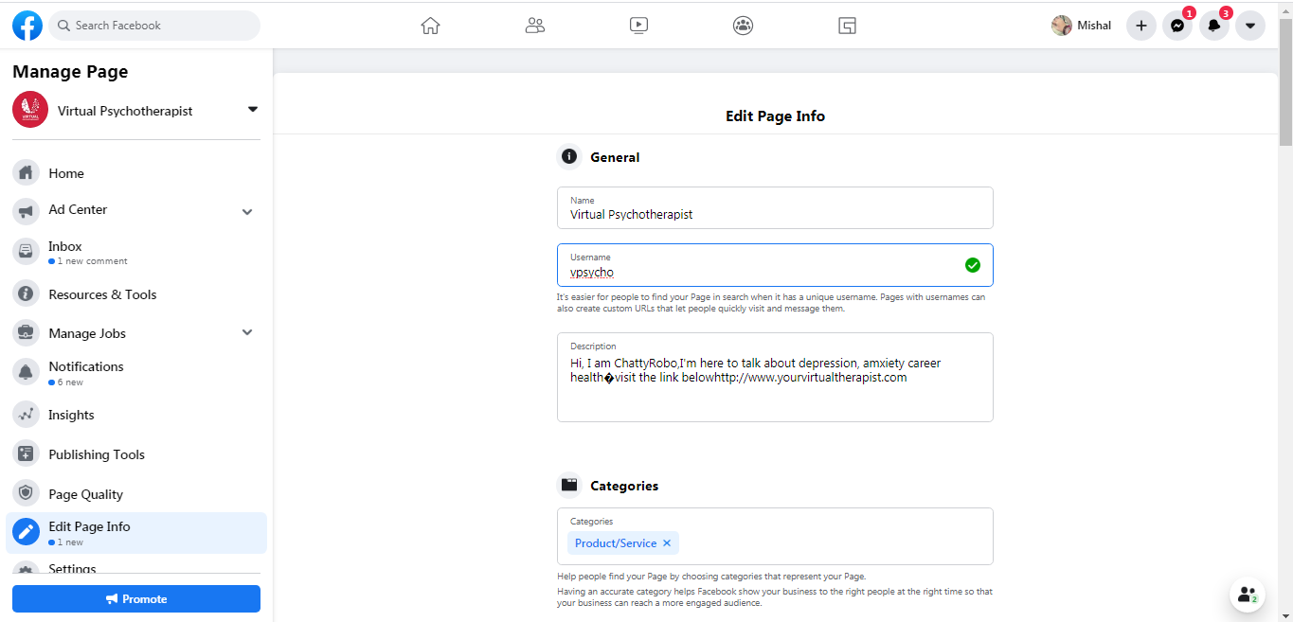

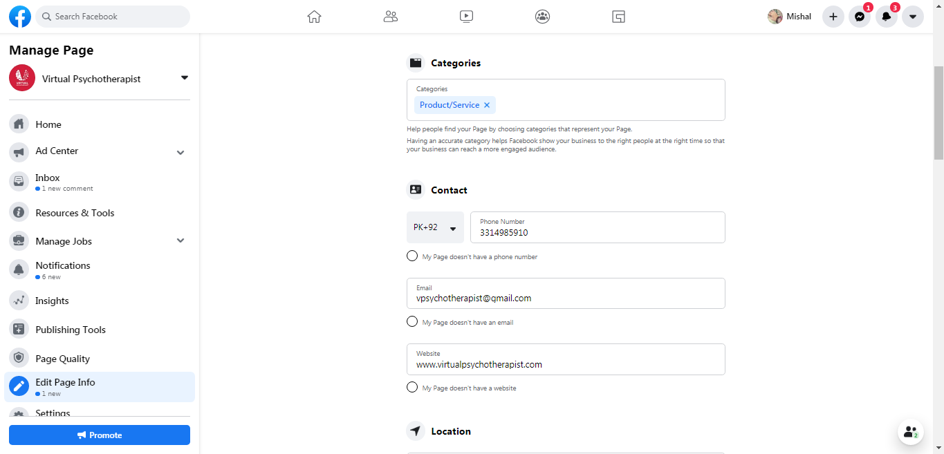

**Create Post:**

We can do posts on this platform by using **Create Post** feature of Facebook. The post can be shared in groups as well.

**General Privacy Setting:**

We can also manage **Privacy** of our Facebook Page from page settings. We can manage who can see our post, who can comment, who can tag and other settings.

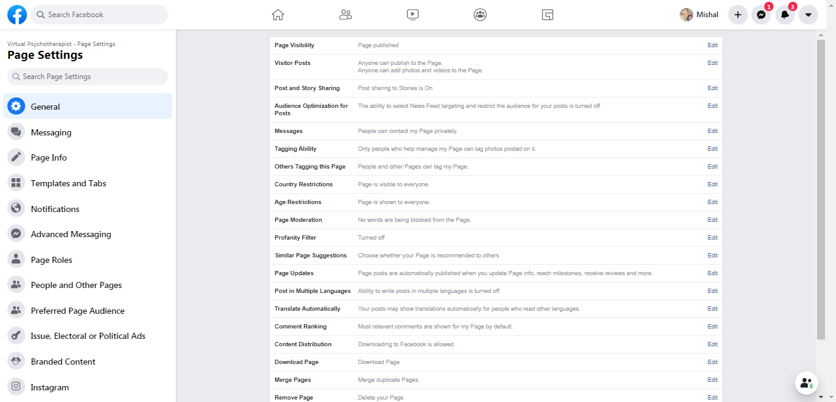

**Facebook Page Roles:**

We can also manage Facebook Page Roles from settings.

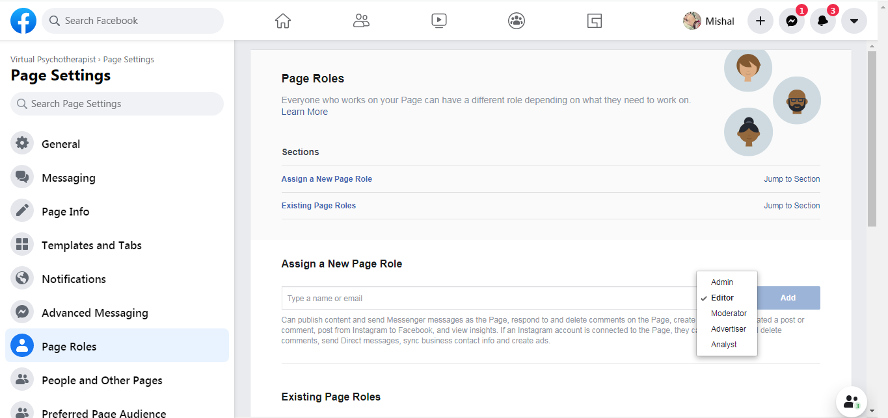

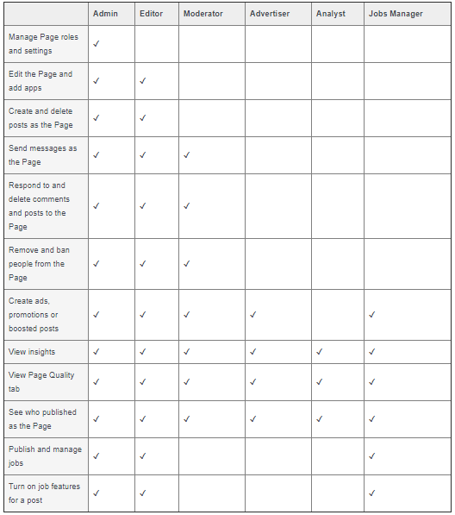

**Instant Messaging:**

This the feature that Facebook Page provides in order to send a custom message instantly from business page when a customer send message in inbox.

**Business Template:**

Facebook also provides different layouts/templates according to the nature of business. We can anytime choose one.

**Hashtags, Check-ins, Tagging:**

This is also the very important feature of Facebook Page. We can use hashtags (#virtualpsychotherapist) in our posts to get mor reach. Facebook also provides check-in and tagging feature to tag people in your group or friend list.

**Let’s have a look on Virtual Psychotherapist Facebook Page:**

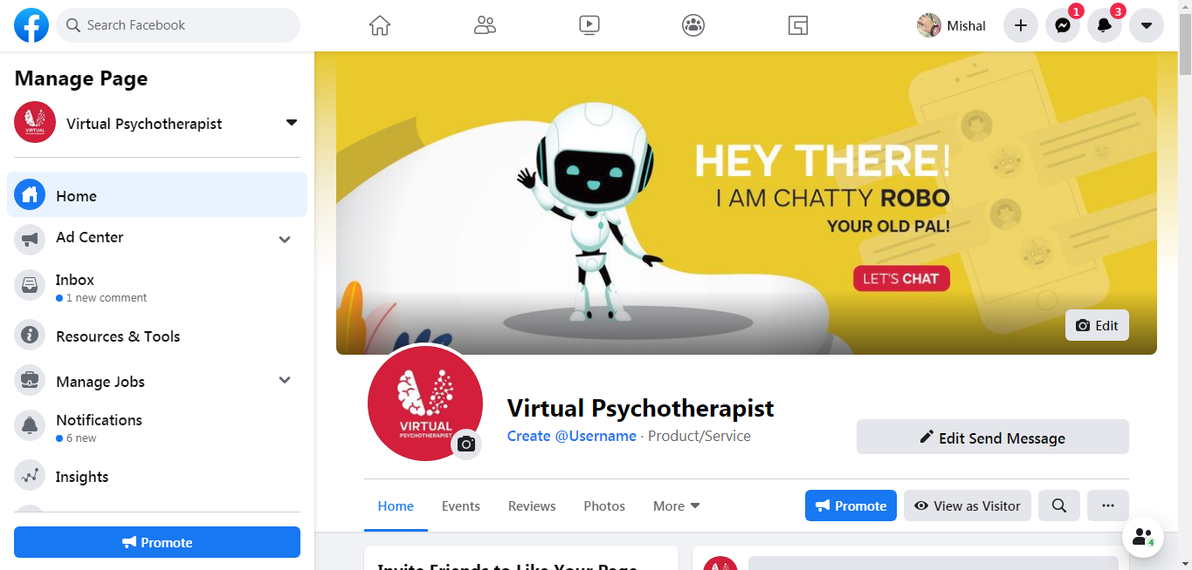

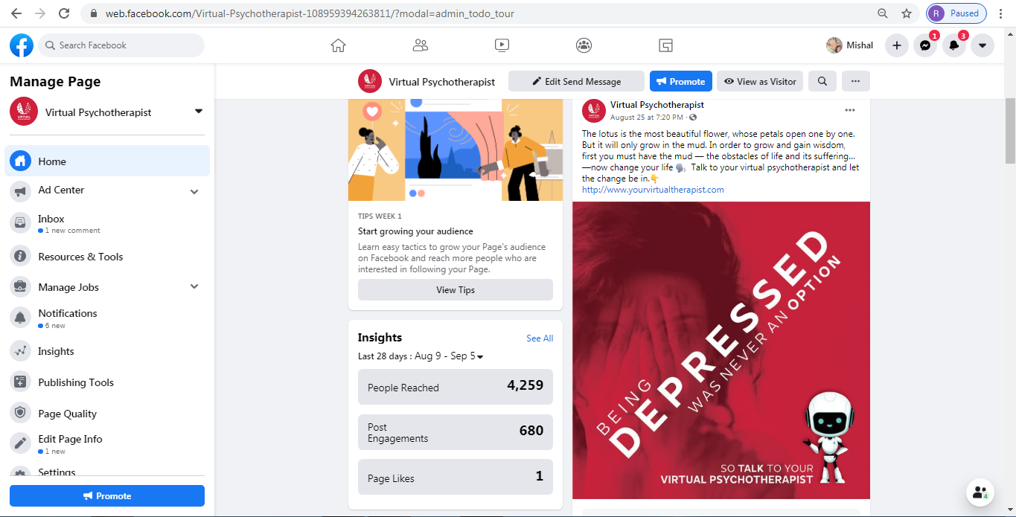

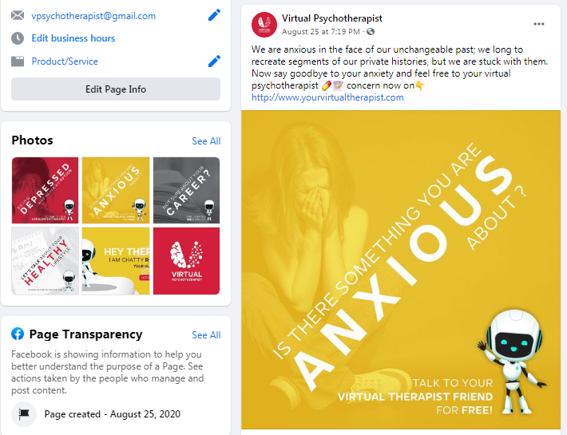

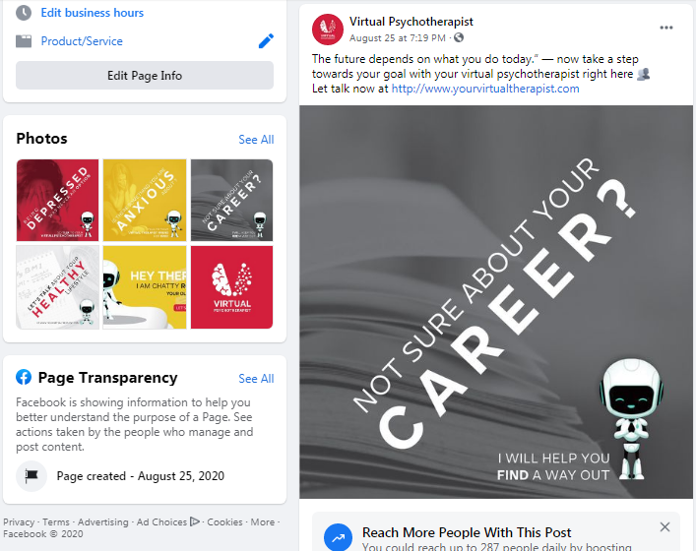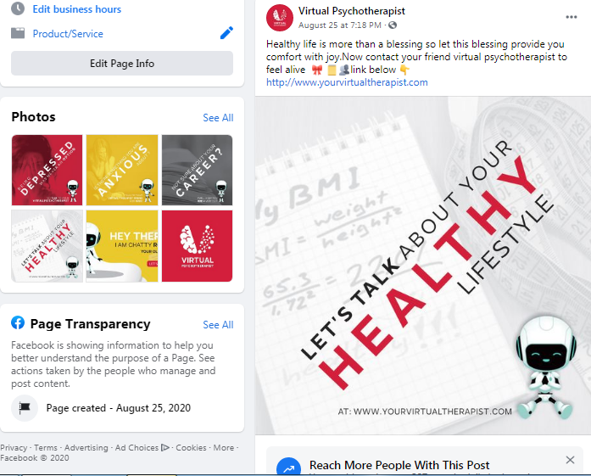

**The Concept of Organic and Paid Reach:**

The number of people who visited the page and saw the posts naturally or without any payment is considered as Organic Reach of a post.

On the other hand, as the name implies, this type of reach is got through payment in order to get fast results. This is targeted reach.

**Facebook Ads:**

Now to advertise our posts, we use Facebook Ads Manager. This tool provides a complete platform to promote our posts to get fast reach and customer engagement.

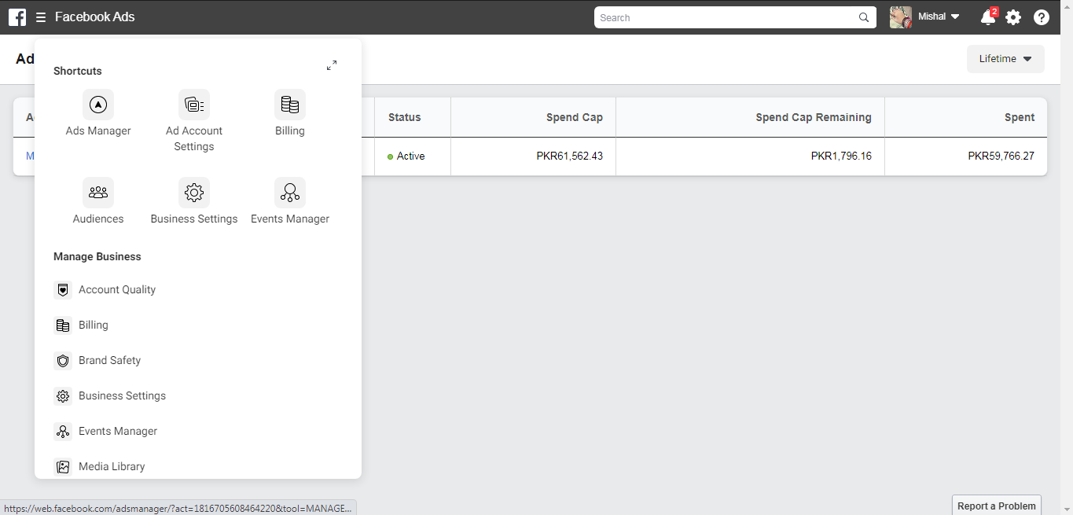

On the top left corner, we can see Ads Manager option. This is how a Facebook Ads Manager looks like:

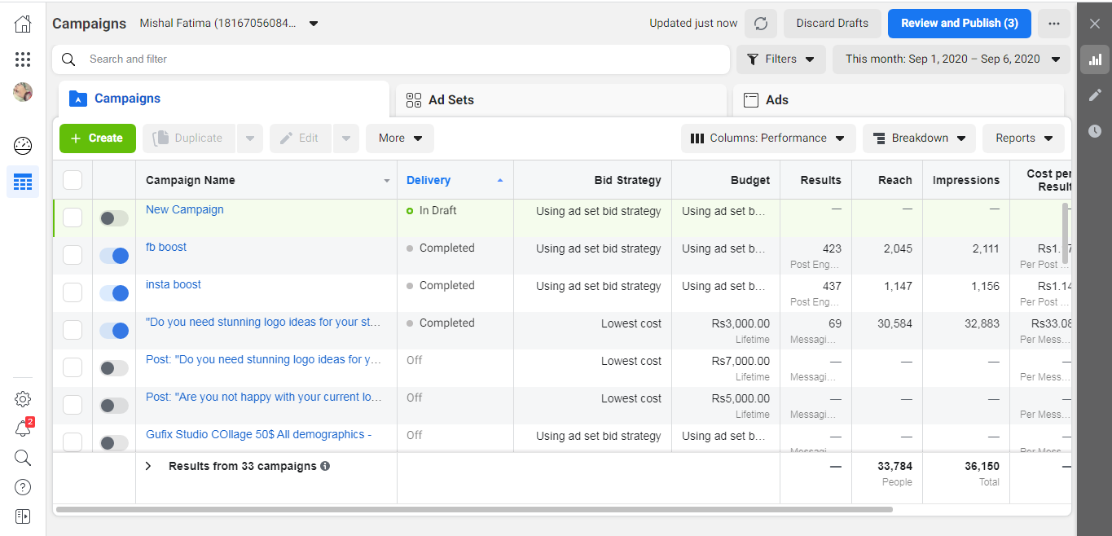

This platform provides an option to Create A campaign. It also gives information about the active and completed campaigns.

**Campaign of Virtual Psychotherapist:**

By clicking create campaign button, Facebook asks for our objective. This is how its interface looks like and we have selected Engagement from the options given.

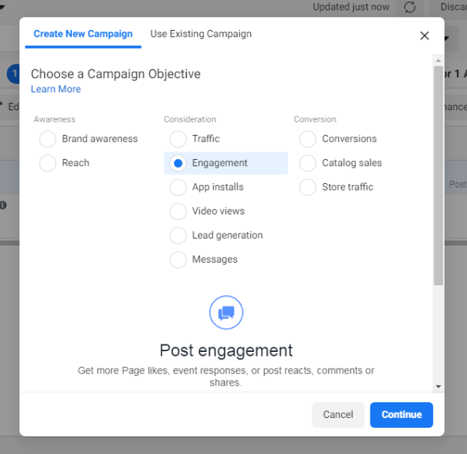

After choosing an objective we need to start, we need to set an ad from Facebook ad set. In this section we need to set budget for our promotion, start date, end date, audience, locations, age, placements and demographics. Demographics include interests of people.

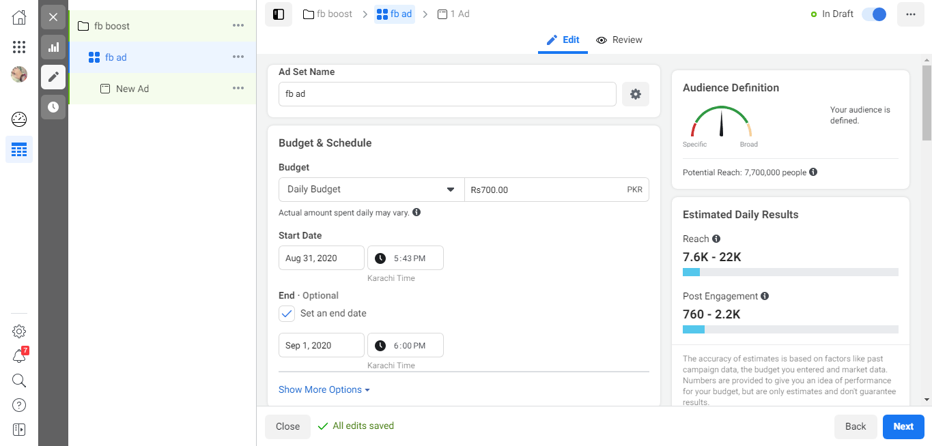

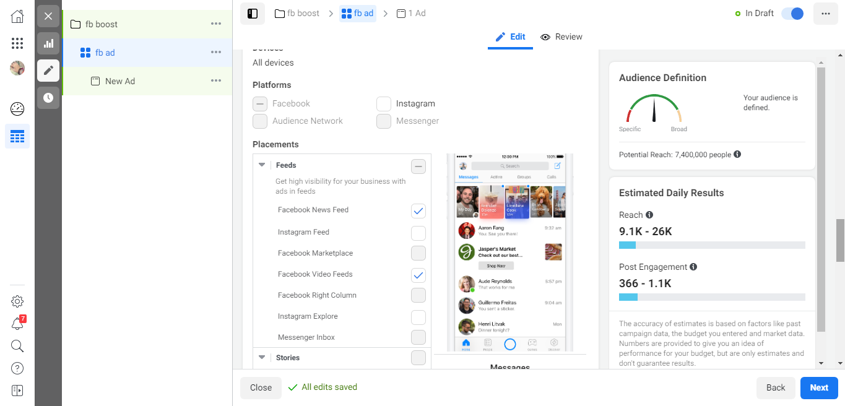

Now to proceed further, we will click on Next button and will choose a **Creative (Post)** for our promotion.

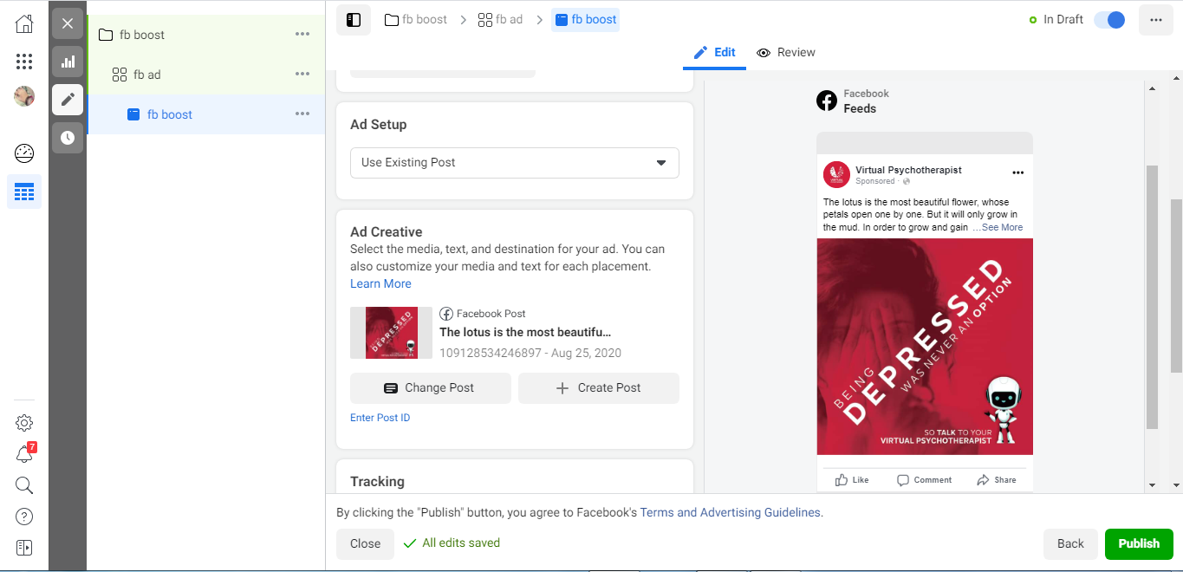

After choosing a Creative, we will click on Publish. Our post will go for a review by Facebook to make sure that we have not violated any Facebook Policy.

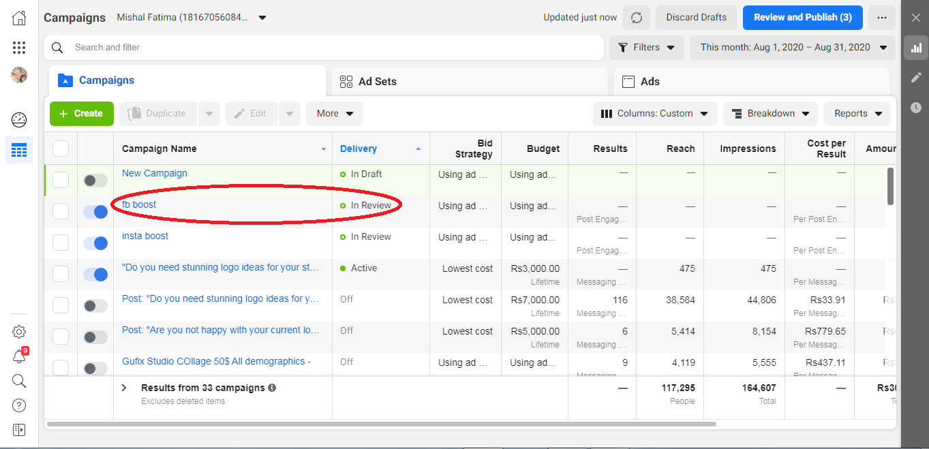

After sometime, Facebook ad will be Active. And Facebook will start spreading the post for maximum reach according to the budget given. After the completion of ads, we check analytics of our ad.

**Facebook Analytics:**

Facebook analytics provides essential information of our audience. It demonstrates who are audience is. We can check the detailed results of our ads from Facebook Analytics.

**Facebook Audience Insights:**

Facebook Audience Insights is a newly launched powerful tool to check insights or interaction of people to our Facebook Page. It also shows the affinities and demographics to the respective keywords.

**INSTAGRAM:**

Instagram is a social media platform that allow user to create image and video posts. Instagram provides an interface for business account as well. we can switch from personal to business account anytime from settings. [8] There are 1 billion active users of Instagram monthly. 500 million people daily use Instagram. [8] These can be our estimated potential customers.

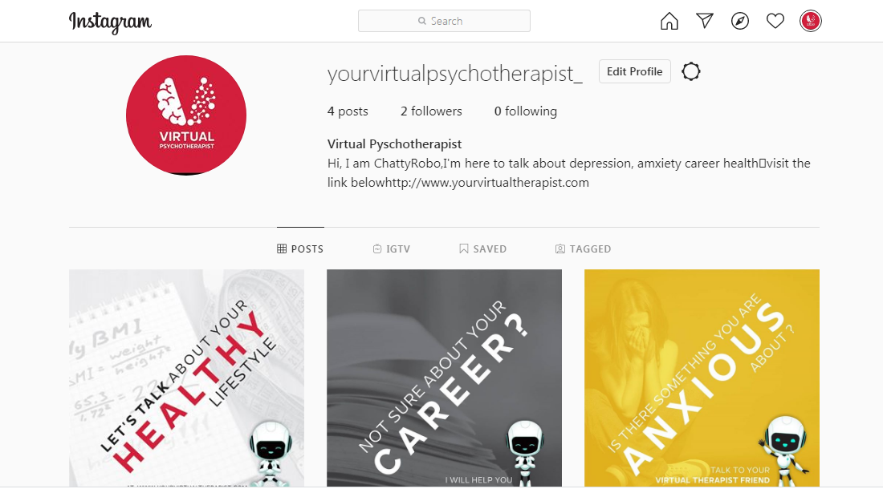

**Facebooks Adverts for Instagram ads:**

Instagram is owned by Facebook. So, we use the same Ads Manager as of Facebook. The procedure of creating an ad for Instagram is same as Facebook. All we need to change is the placements of our ad to Instagram Platform. We have already explored how to create a campaign, ad set, and ad group for ads. We will now just change the placement of our ad.

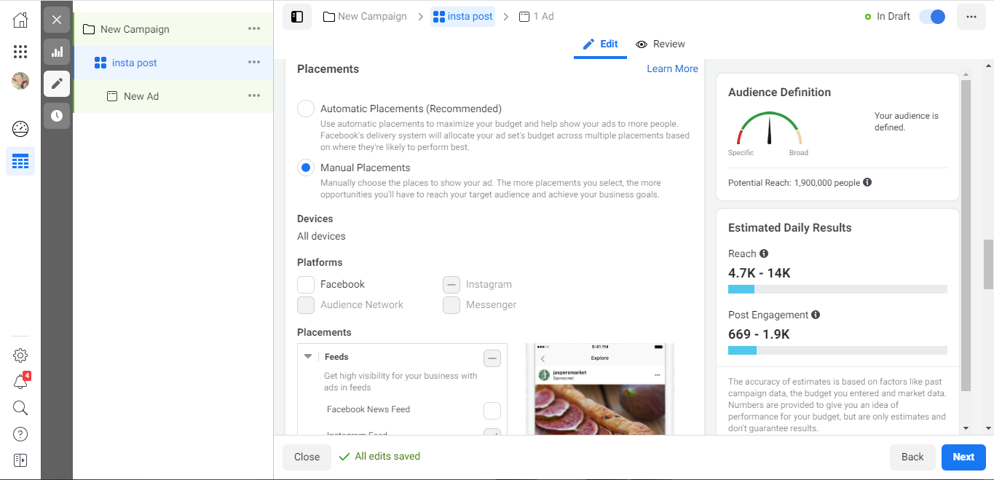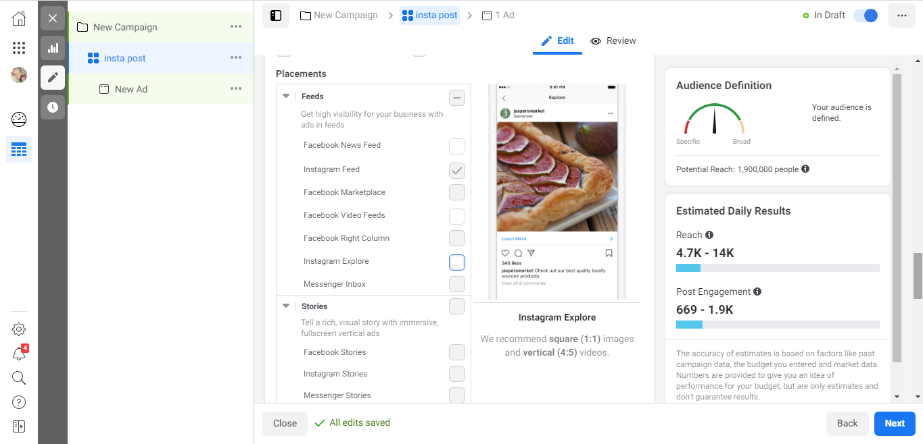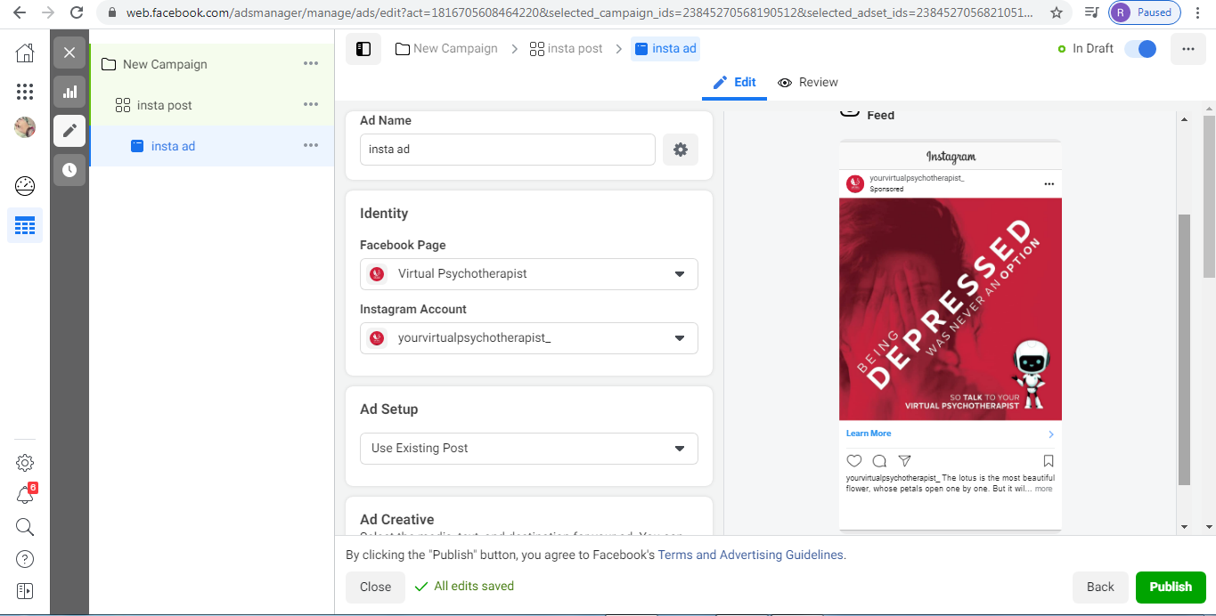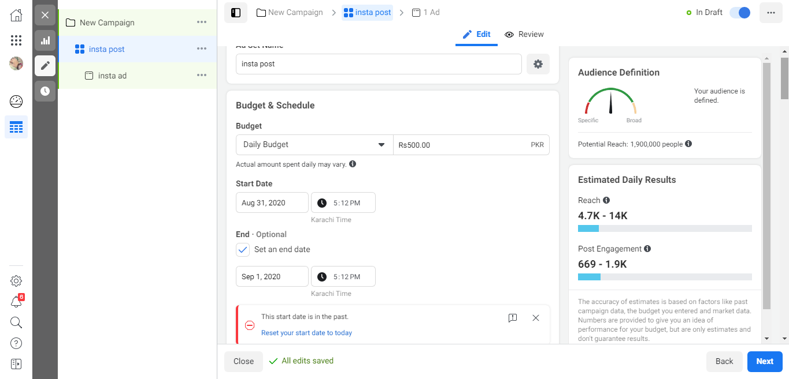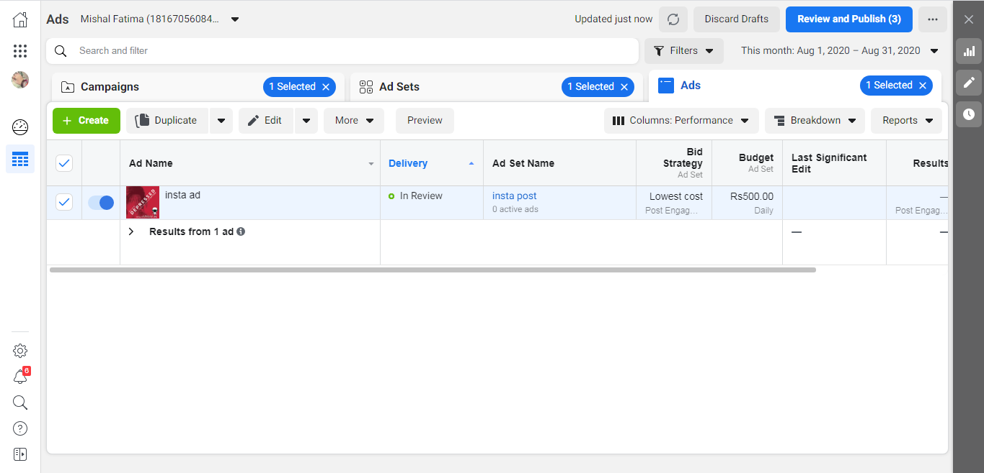

**Results from Facebook and Instagram Ads:**

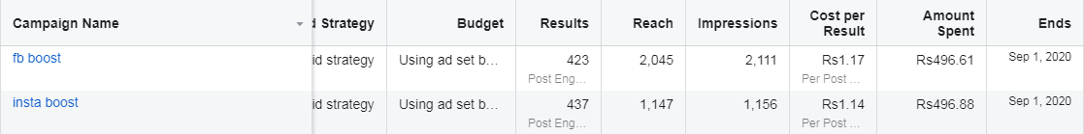

Comparatively, we got maximum reach on Facebook. But as we can see we got maximum post engagement on Instagram with comparatively lower reach than Facebook.

**TWITTER:**

Twitter is an online social media platform widely used for official announcements. This is the platform mostly used by politicians and large businesses. This platform gives high conversion rate. It also serves with quick customer support. To get maximum impressions we need to tweet timely and effectively. To get viral on twitter we can use twitter pols, questions, ‘TOP’ and ‘How To’ keywords.

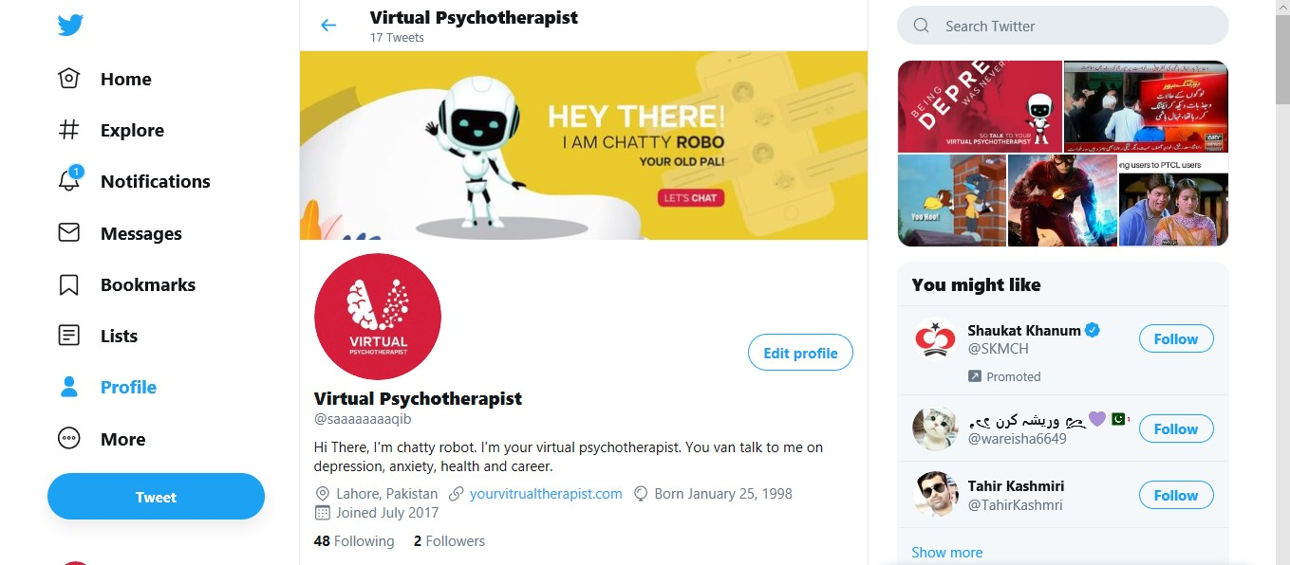

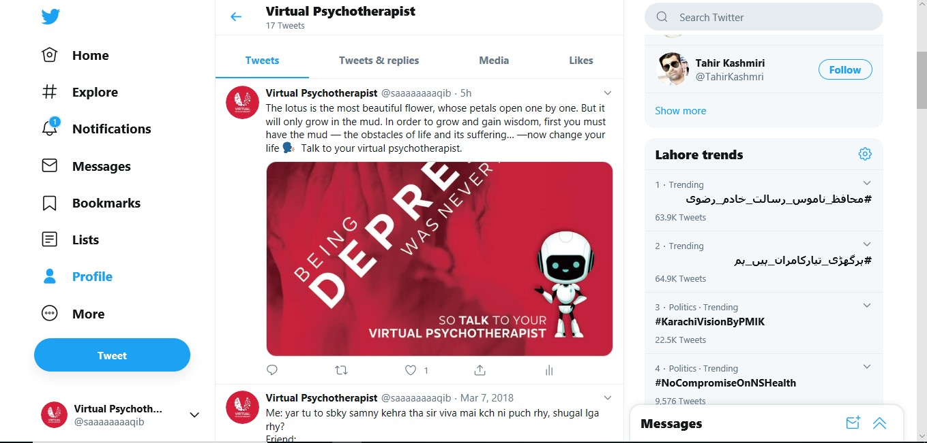

**Twitter Business:**

Twitter business allows us to create ads for promotions. From ads manager we can create a new campaign according to our objective. After choosing our objective, we will proceed towards demographics, budget, start and end date, locations, placements, add creatives, payment methods and other essential features.

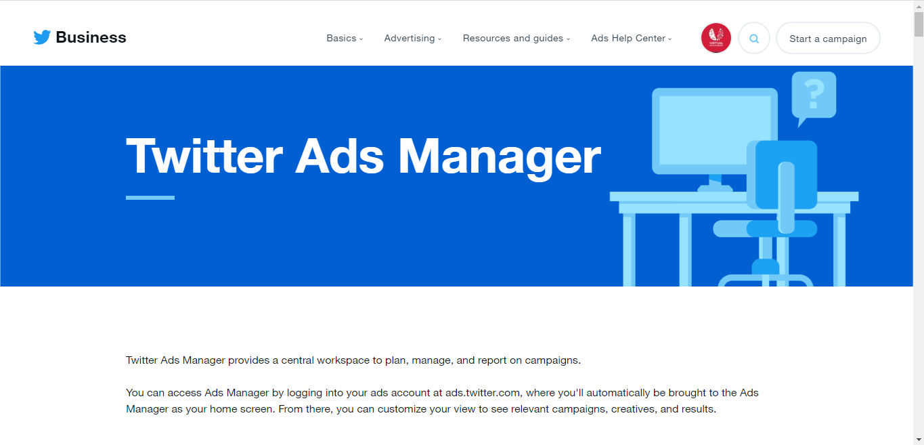

**Twitter Ad Campaign for Virtual Psychotherapist:**

This is how we created an ad for twitter and promoted it:

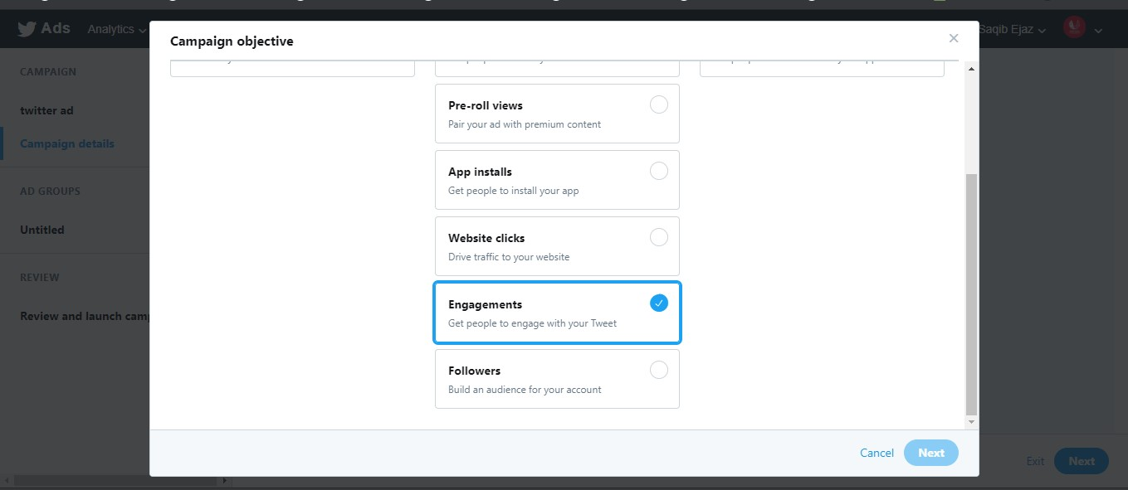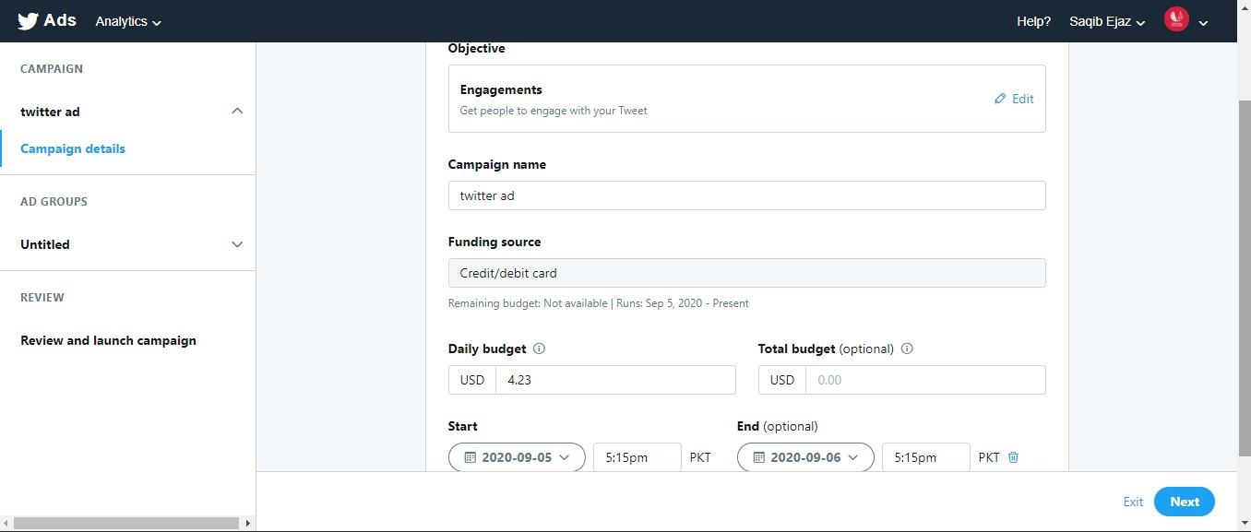

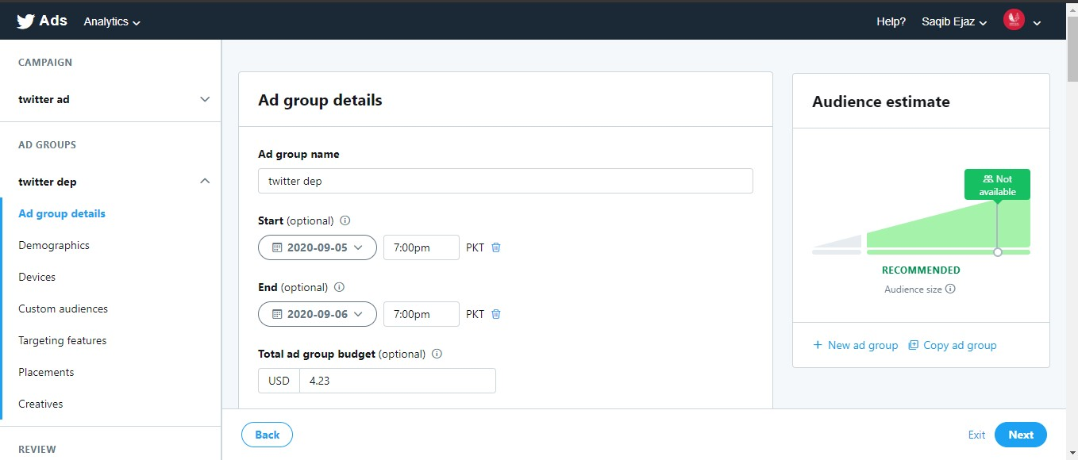

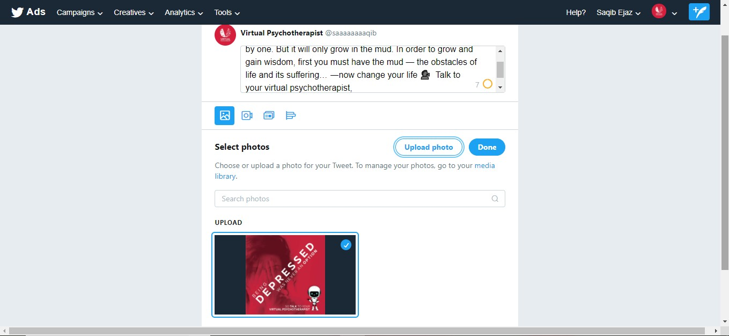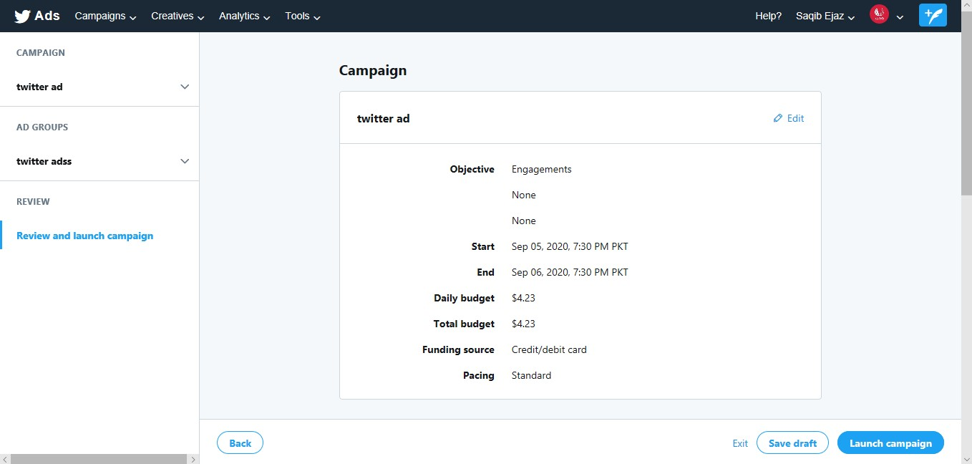

After setting all the information, we will Launch our campaign. The ad will go for a quick review and will start responding.

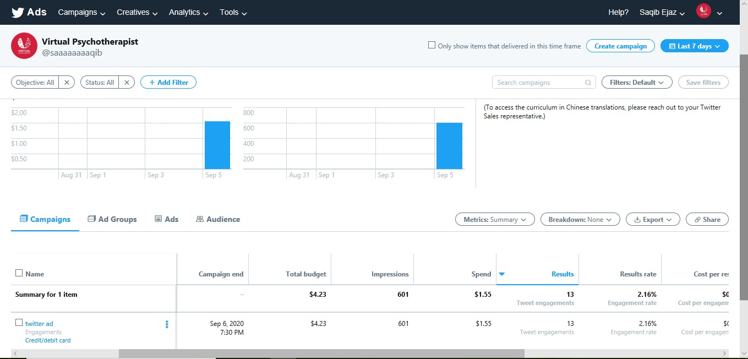

**LINKEDIN:**

LinkedIn is the world’s largest professional network on the internet. It is a platform that focuses on professional growth and career development. People can post their resumes, search posts, and can grow their professional repute through daily updates and interaction with the people. LinkedIn is all about building connections. The more connections we build the more opportunities we can get.

To take a start with LinkedIn, we need to create a professional profile after signing in. A professional profile looks like this:

Images of Saqib’s profile.

We can also create a company page on LinkedIn for daily updates of our business or work. We can share these updates with the people. We can also create LinkedIn campaigns to promote our business. LinkedIn does not provide ads services in Pakistan. We can have a look on its interface for other countries.

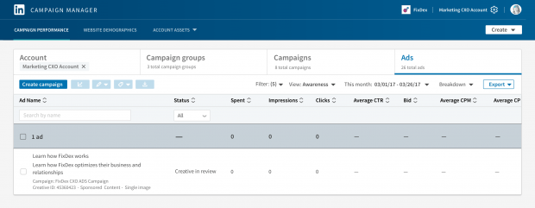

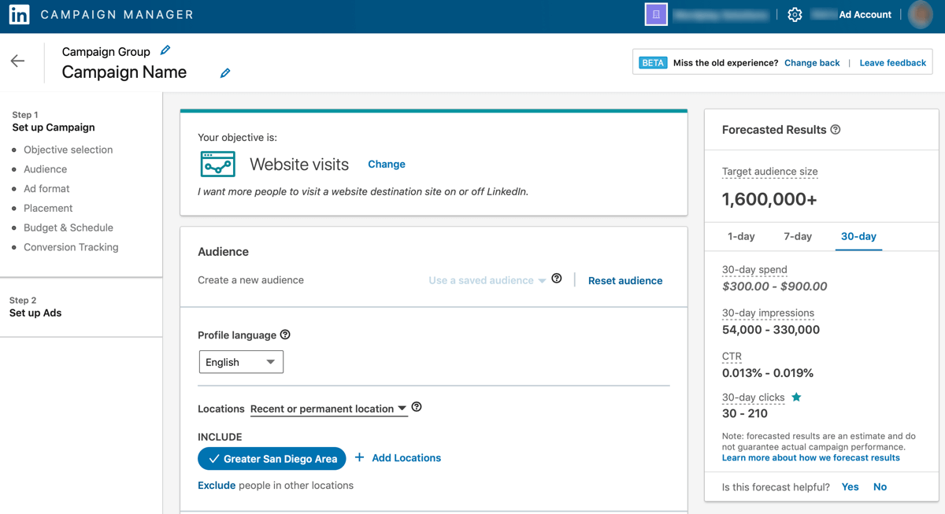

**YOUTUBE:**

YouTube is a widely used online video sharing platform. It allows users to watch videos of their interest with facility of internet. Users can download videos on YouTube and can watch these videos later with no internet service.

Various type of content is available on YouTube such as humorous, motivational, storytelling, instruction videos with ‘how to’ tags, teaching videos, singing videos, and much more.

Users can also create their own YouTube channel and can earn money on the basis of views and subscribers. Minimum requirement for monetization (to earn money) is 4000 watch hours and 1000 subscribers. After achieving this goal, YouTube will monetize the channel for earning.

YouTube is a powerful digital marketing tool. It also gives high traffic. Certain type of ads can run on YouTube like display ads, overlay ads, skippable or non-skippable ads and bumper ads.

**YouTube Studio:**

YouTube studio is the platform provided by YouTube to manage our channels, videos, insights and other settings. It is fast and easy to use. Let’s have a look how we uploaded our video to YouTube:

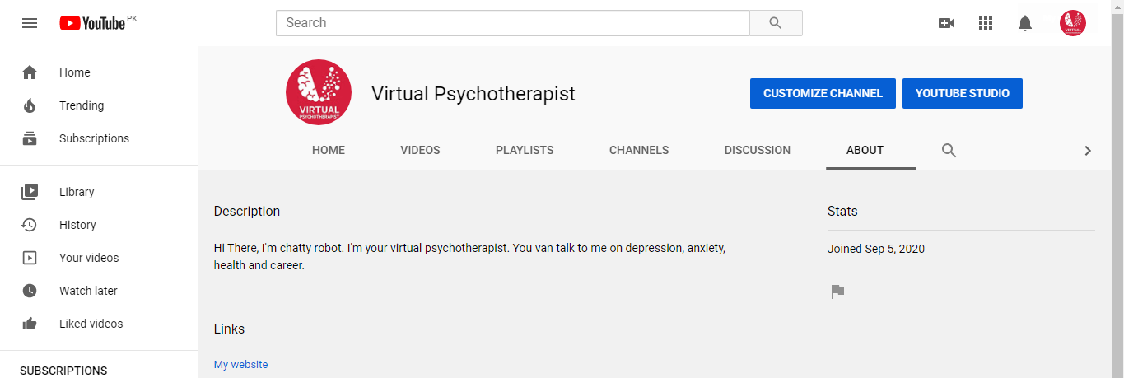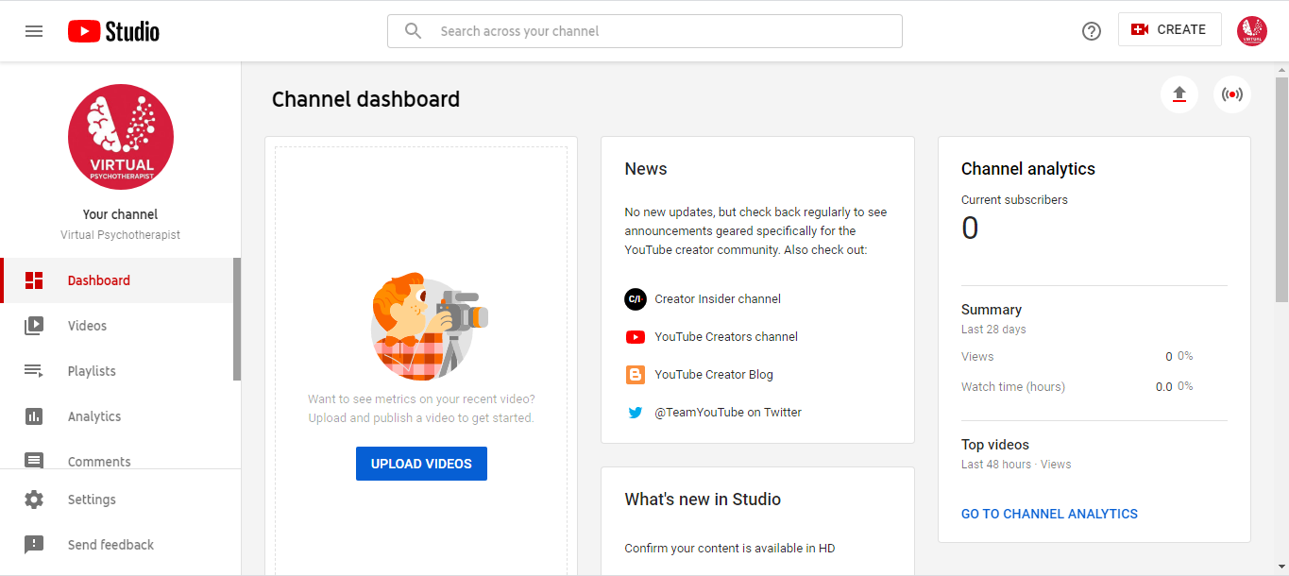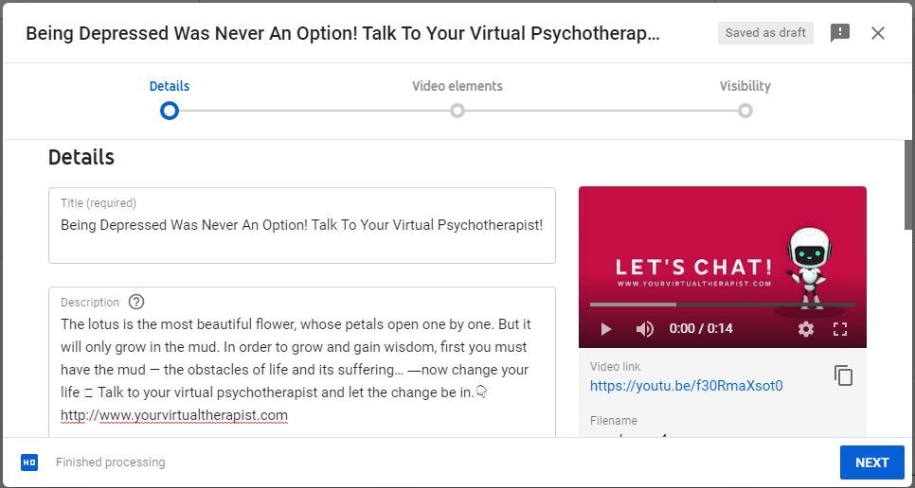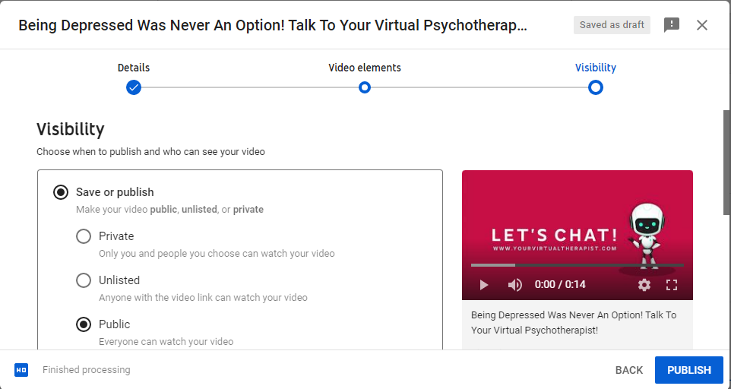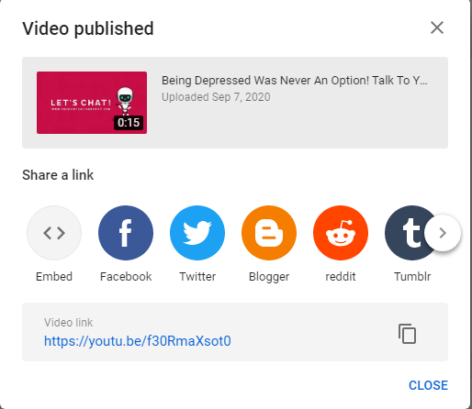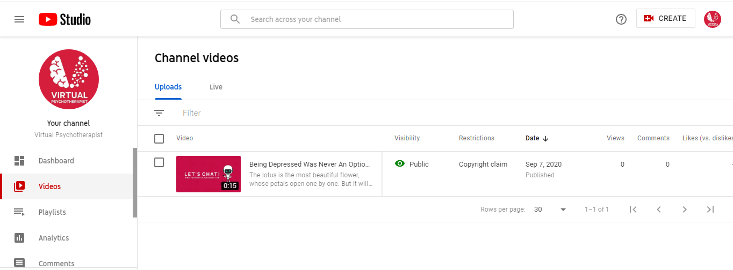

**YouTube Ad Campaigns from Google AdWords:**

As we know that YouTube is owned by Google. So, the platform we use for YouTube Ad Campaigns is Google AdWords. We have discussed Google AdWords in detail in the section below. We have also created a Skippable YouTube ad from Google AdWords.

**TUMBLR:**

Tumblr is also a social networking website and an application. It is a place where people express their self. It is a platform that allow its users to post text, images, photos, gifs, videos and much more. It is the place where interests help people to connect with people. [7] There are 472 million registered accounts on Tumblr. [7]

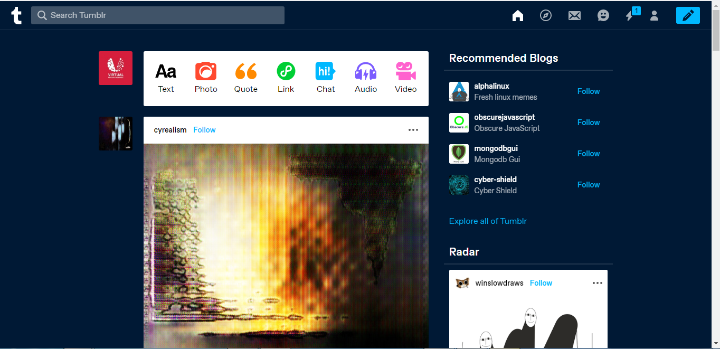

**Our Virtual Psychotherapist on Tumblr:**

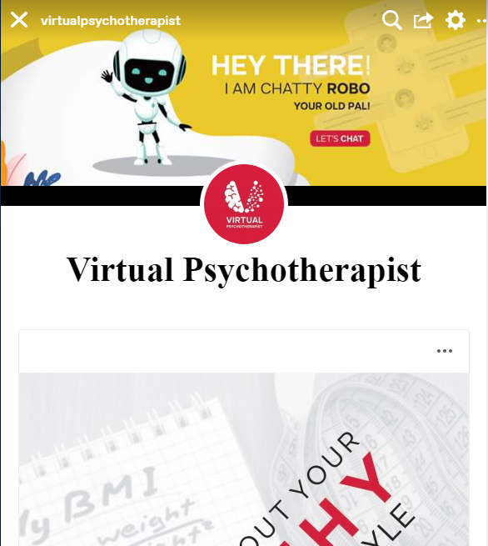

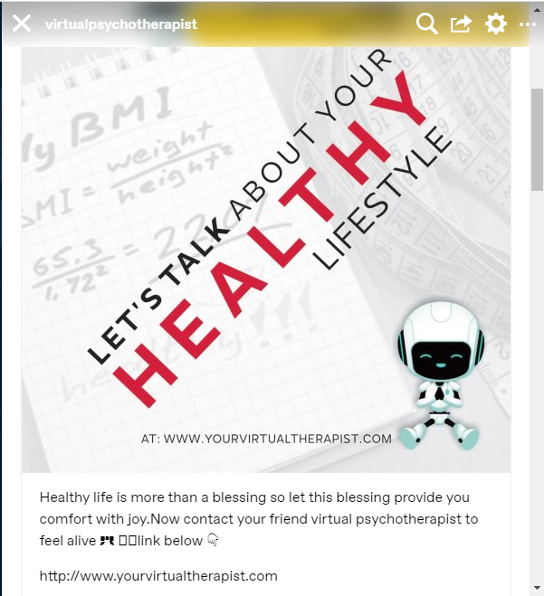

**Settings for Tumblr:**

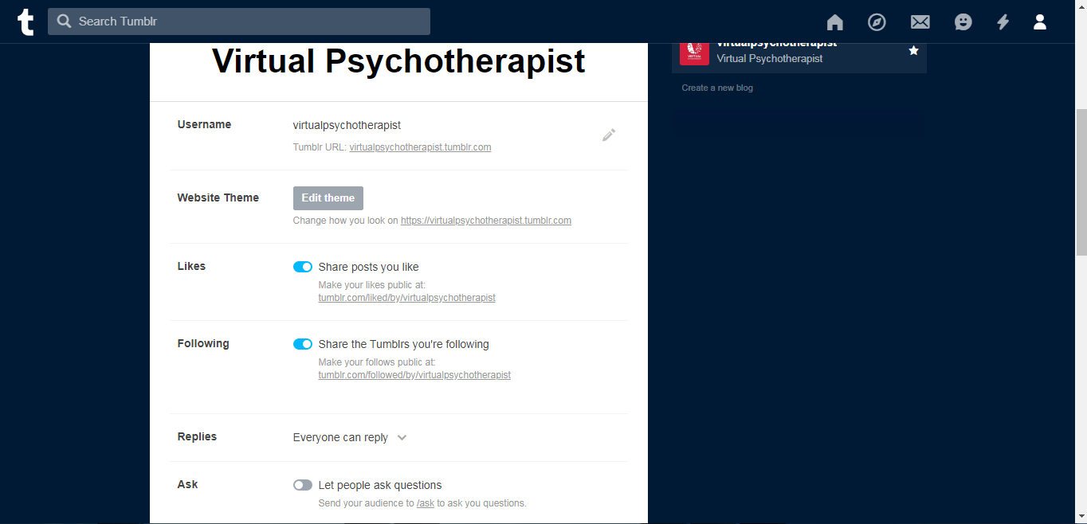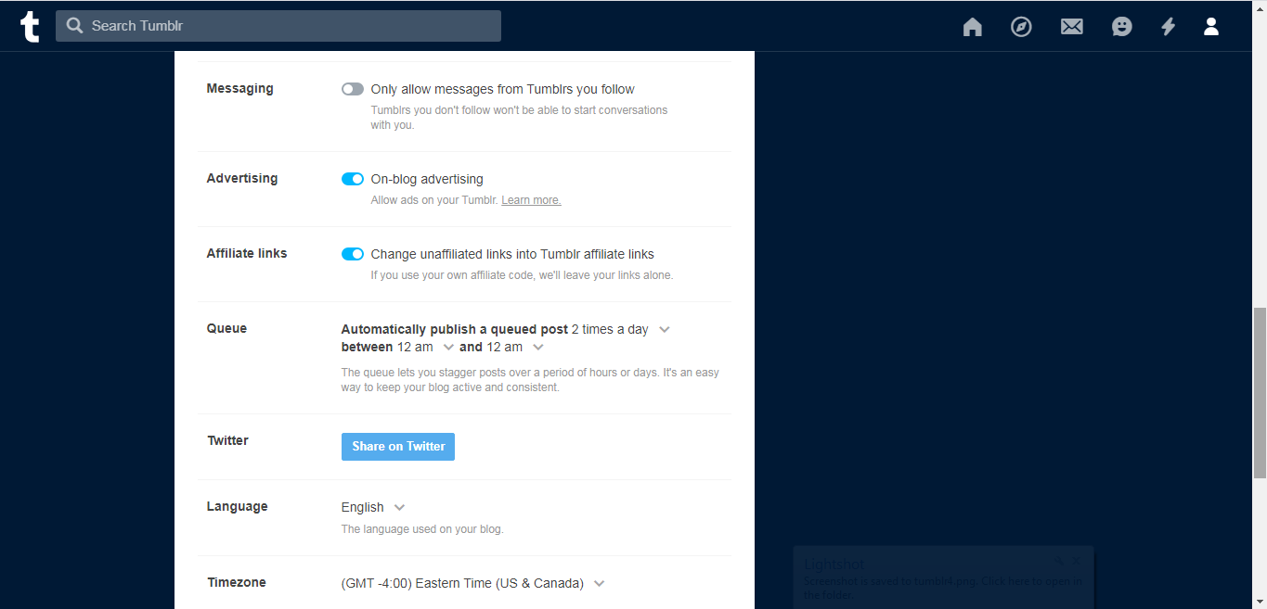

**Tumblr Business:**

Tumblr Business allows users or companies to Contact Brand Strategists for the promotion of textual, image or video ads.

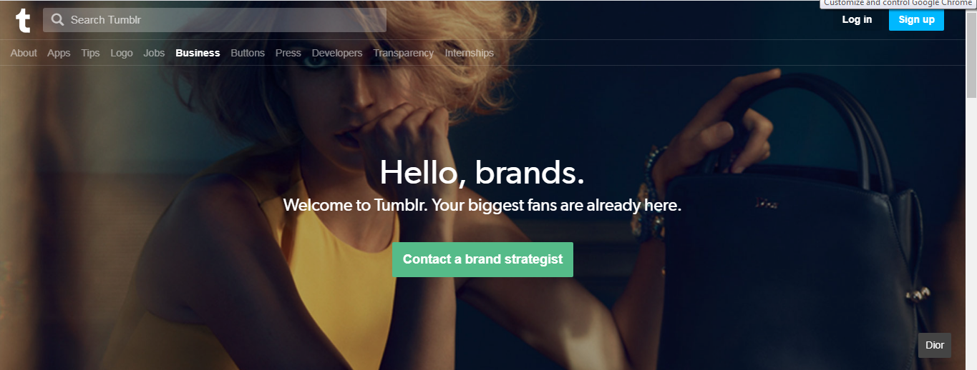

**SNAPCHAT:**

Snapchat is a mobile application for android and iOS users. To give a more natural feeling on this platform, the snapchat stories are available for users for short period of time. After sometime stories will disappear. This gives users a more natural feeling regarding daily life. This app allows users to send stories, short videos, chatting and other features. The stories can be shared with friends. Snapchat media can also be stored on private media.

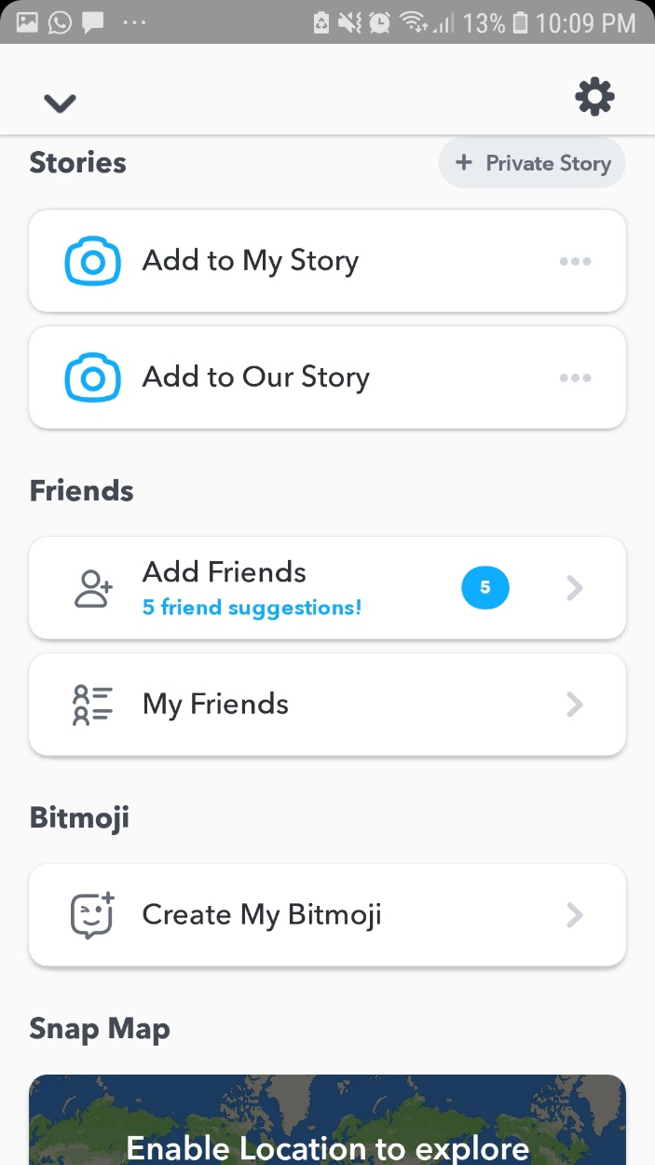

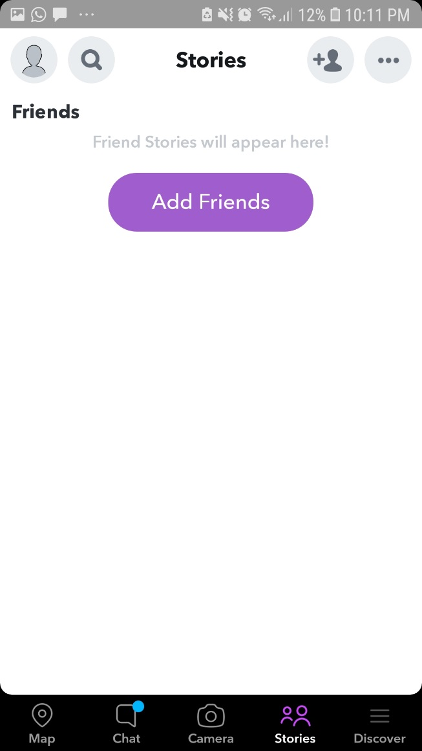

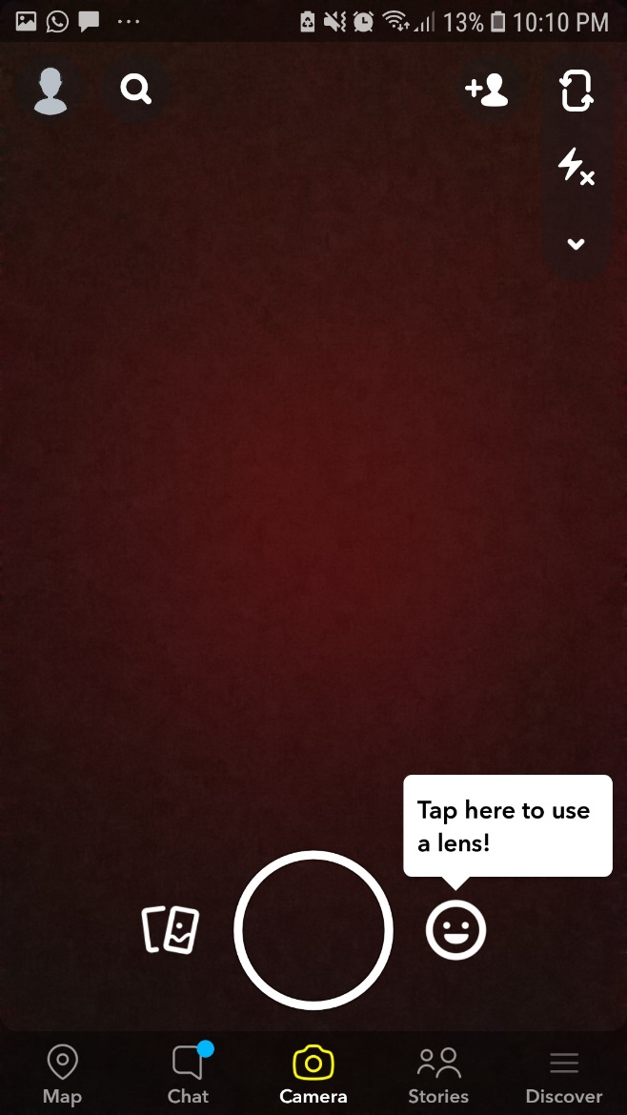

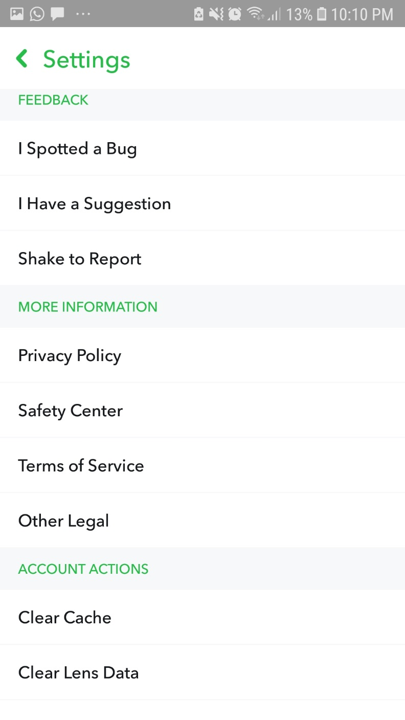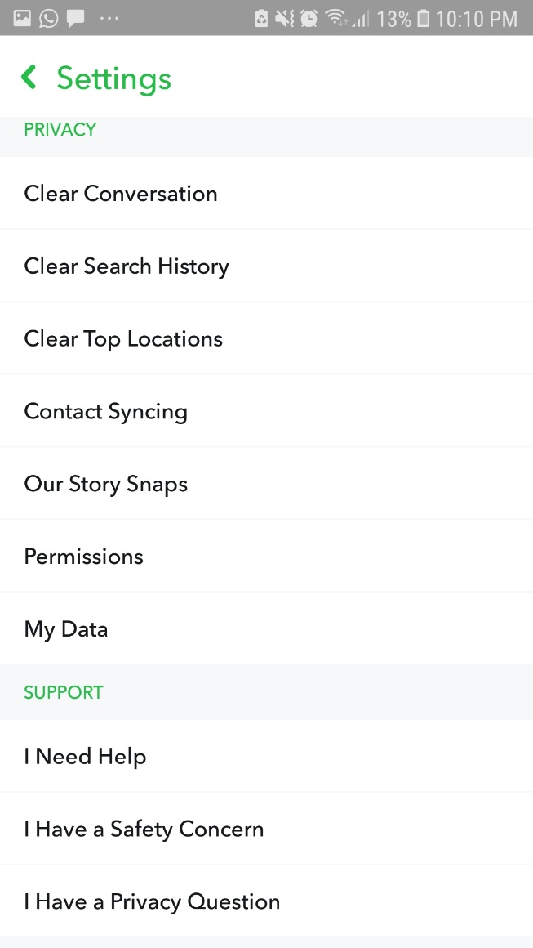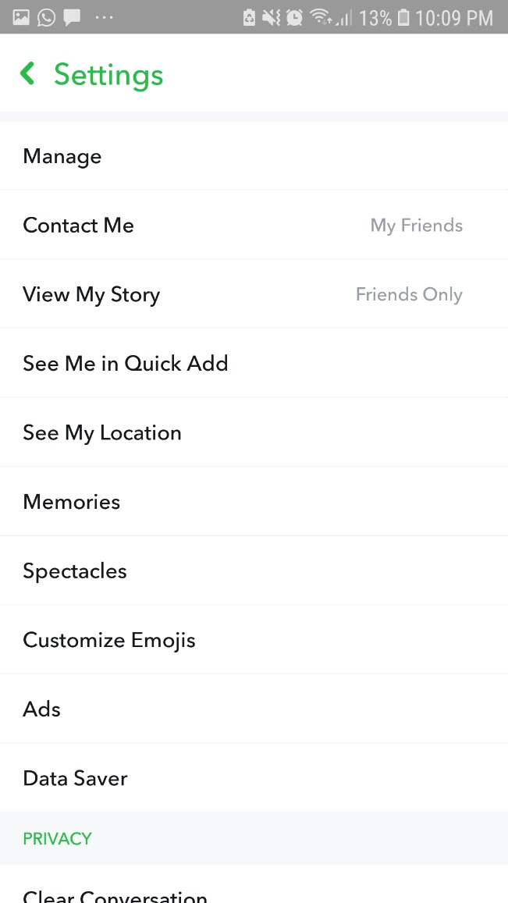

**Snapchat Ads Manager:**

For the purpose of Digital Marketing on snapchat, we can use Snapchat Ads Manage. It Allows companies to promote their products or business by only 1 click. To promote a snapchat story, we need to start a new campaign, make an ad set, set demographics, placements another information. Snapchat does not allow ads promotion in Pakistan. But we are going to review Ads manager for other countries.

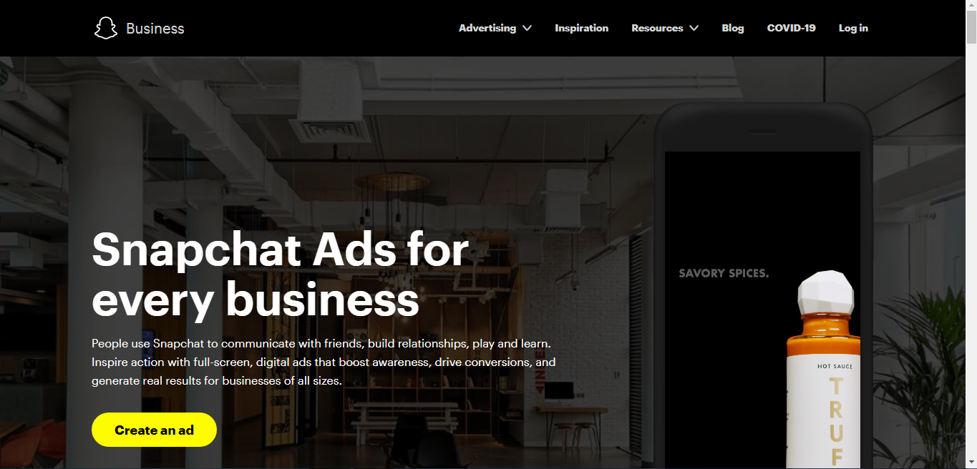

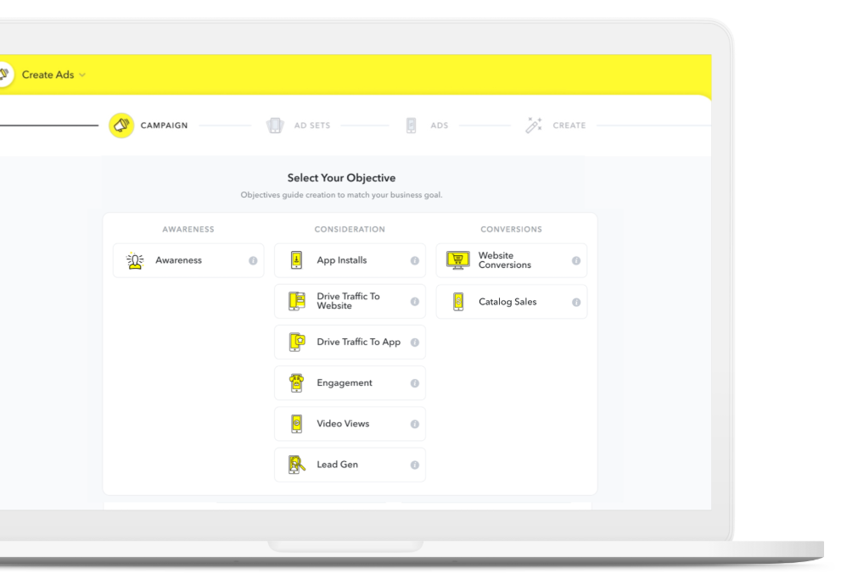

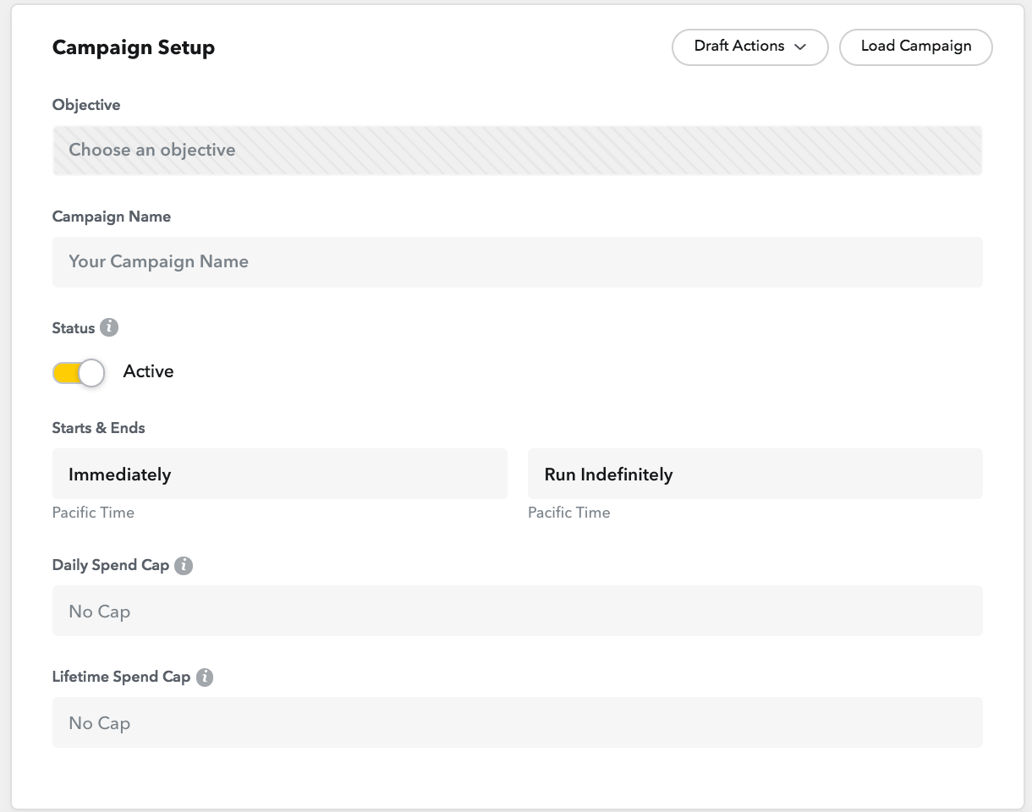

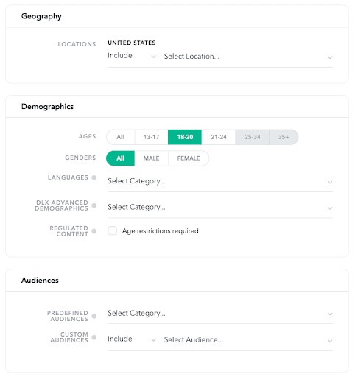

**Snapchat Ads Dashboard:**

Once our promotion of snap is ended, we can check its results from Ads Dashboard. And make the future strategy on the basis of these results.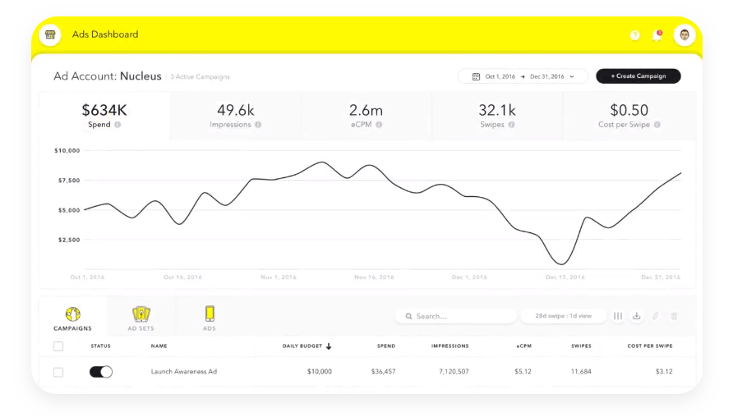

**YELP:**

Yelp is an American Based Company Website and Mobile App that provides an interface to the companies and common people. Companies can make their business pages on yelp. And it gives an environment for the people to give reviews and recommendations. The more reviews and recommendations company will get, more visitors will be converted in customers. But yelp does nor provide services in Pakistan. [www.yelp.com](http://www.yelp.com)

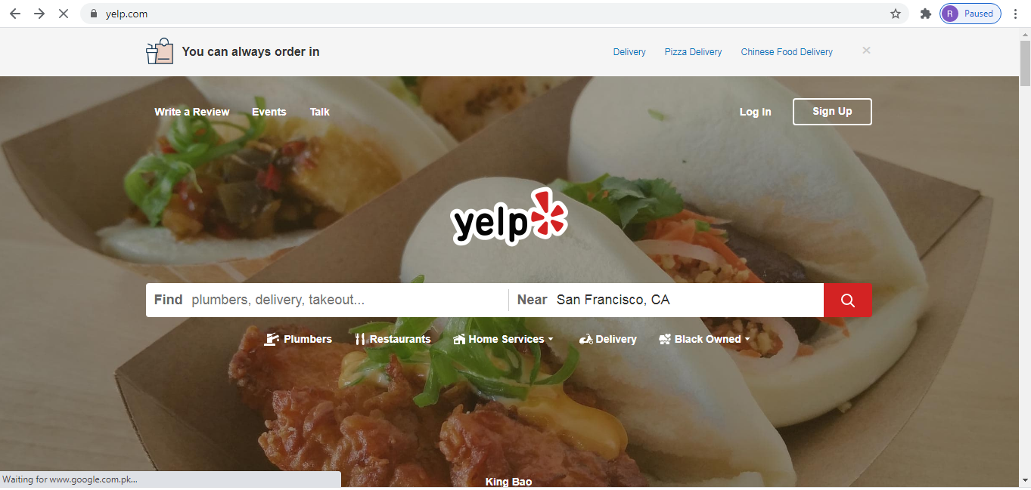

**REDDIT:**

Reddit can also be used as Digital Marketing Tool. It is based on the interest of people. It is a network of communities. People find communities in which they are interested and become a part of online community. It is also a forum where people can share news, films, pop culture, technologies, comics and much more. There are million of active users on Reddit.

As a Digital Marketing Tool, companies can Sign up to the reddit and can share latest updates, news, and other information with the millions of people. This is how its interface looks like after signing in:

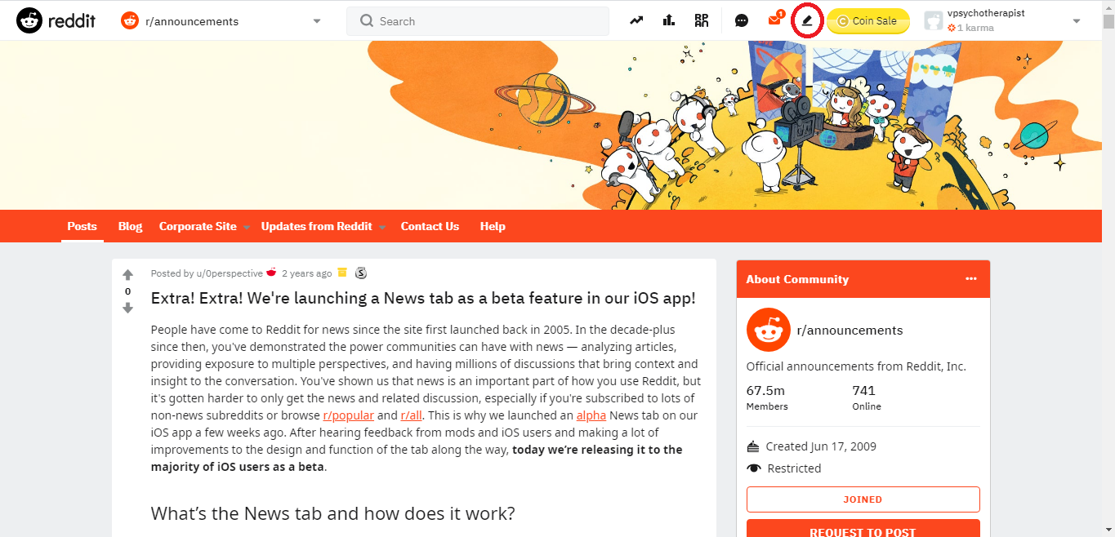

We can create post from the pen tool marked on the top of the menu.

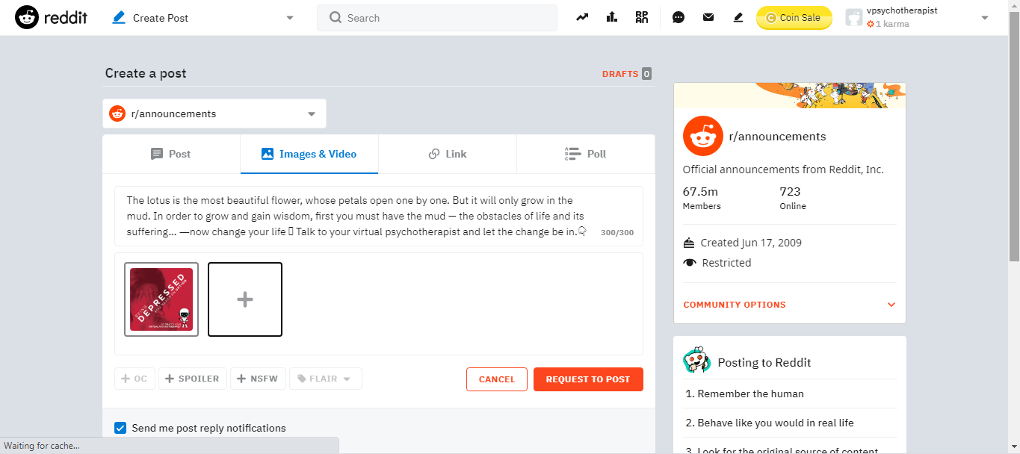

As we can see, we can create a textual post, can upload images or videos, links and we can also create Polls. This announcement will be shown the people. Reddit also provides some premium tools and coins as rewards.

Reddit Coins are a brand-new virtual currency that allows you to reward users (also known as Gilding) for quality submissions and comments they make. ... In addition to showing a Gold Award badge next to the comment or submissions, it also provides the user with one free week of Reddit Premium and costs 500 Reddit Coins.

**PINTEREST:**

There are 400 Million Active Users on Pinterest. It is also an interest based Digital Platform. People can choose their interests and can share and discover new interests which is known as Pinning. It provides a platform to the users to share images on their own or other boards. People can also browse pins of other people on the basis of their interest.

In order to do marketing from this platform, we need to sign up for a business account from <https://www.pinterest.com/business/hub/> . After signing in, an interface will be provided from where companies can create, share and promote their pins.

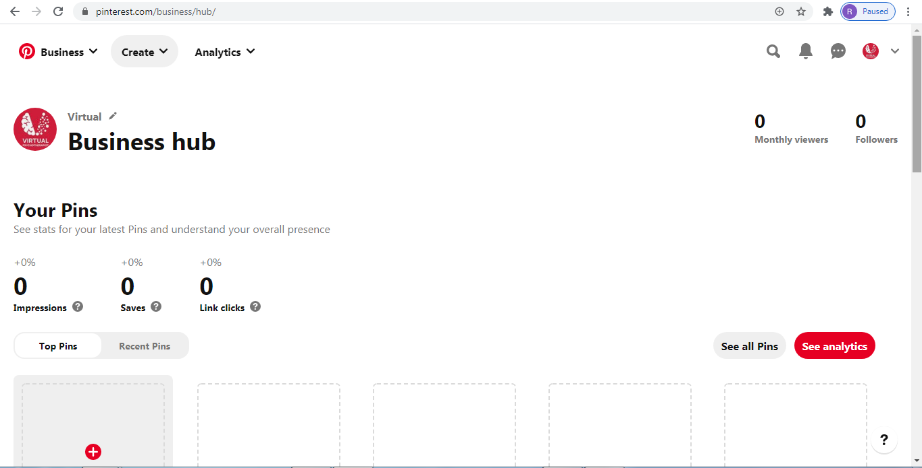

This is how we can create pins after clicking on **Create** Button. We can **Publish** the pin the immediately or we can also schedule it.

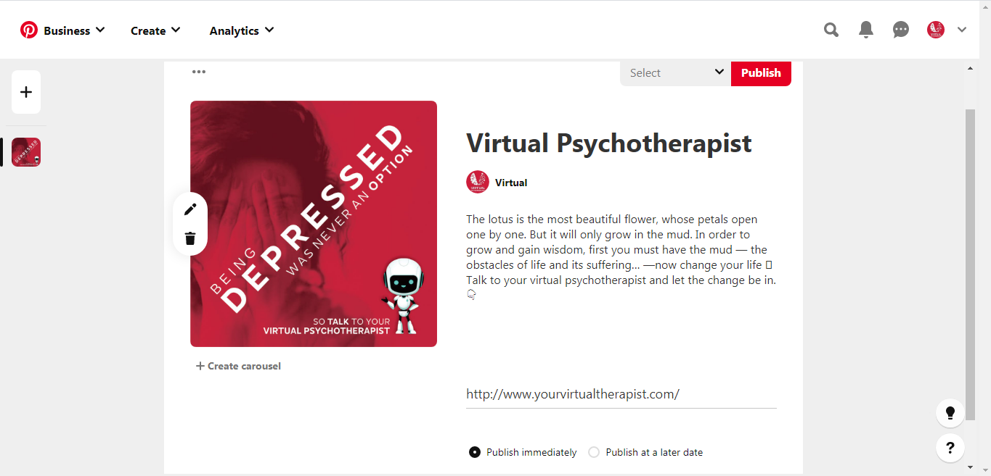

This is how published pins look like. People can comment and save these pins. It also shows the link clicks and impressions.

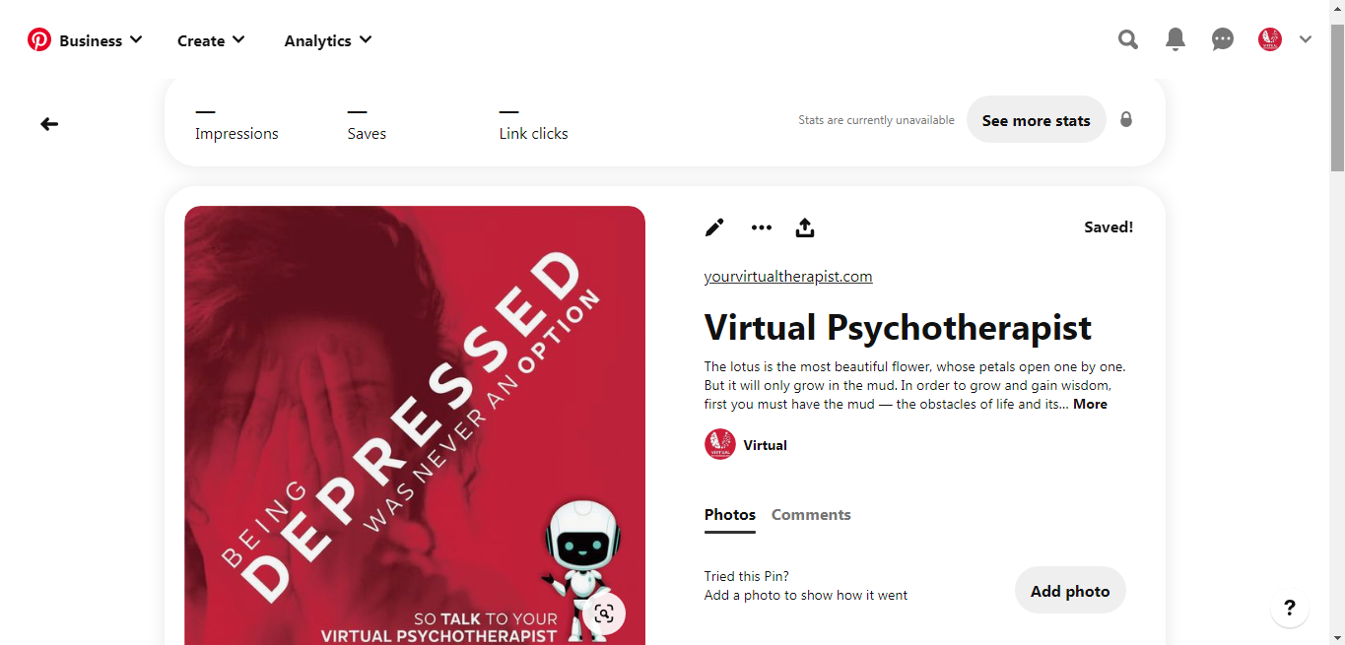

**Pinterest Ads Manager:**

In order to promote our pin, we use Pinterest Ads manager. This is how the interface is:

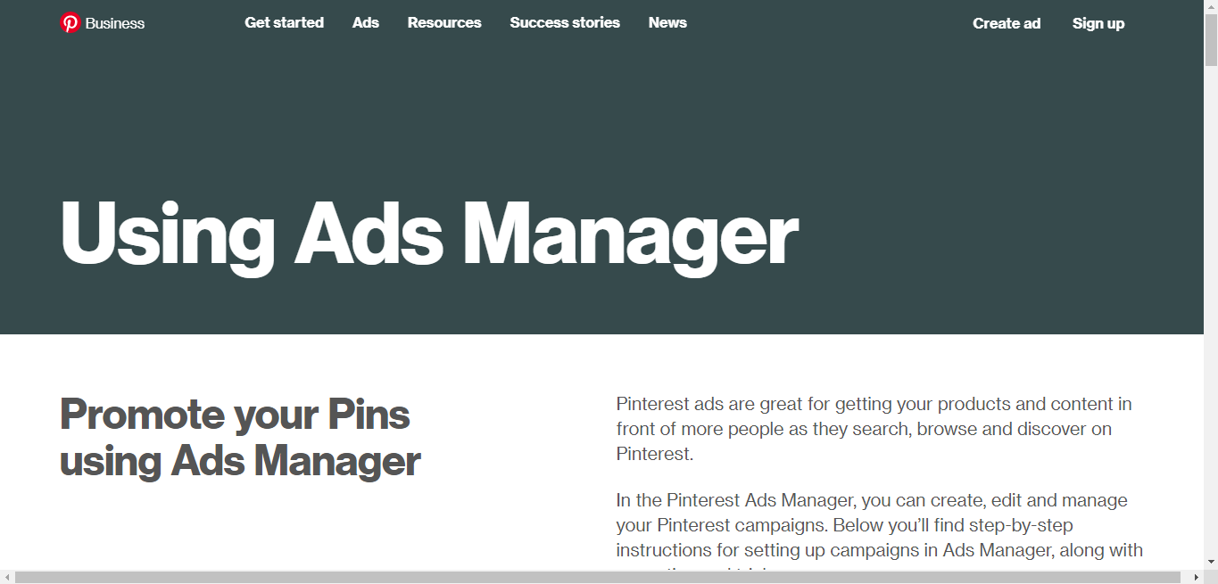

By clicking **Create ad** Button, we can create an ad for our pin to promote it. But unfortunately, Pinterest does not provide ad service in Pakistan. We can promote our pin to the countries Pinterest allows. For now, we have selected United States.

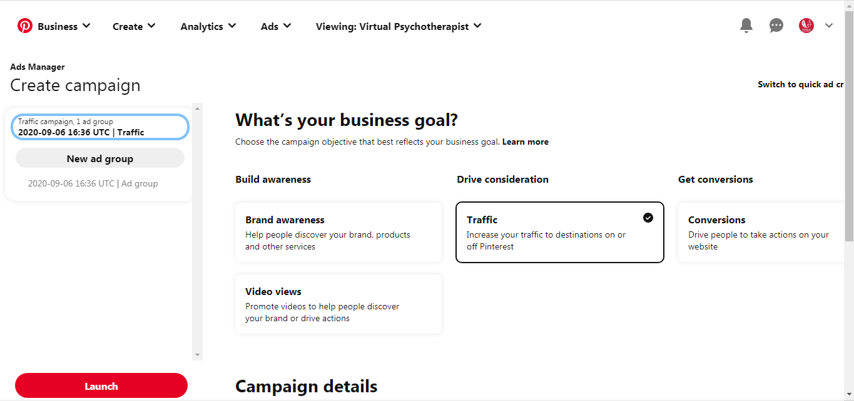

After selecting an objective, it will ask for Ad Group, in which like other platforms, we will give location, demographics, placements, age, gender and other information and launch the promotion.

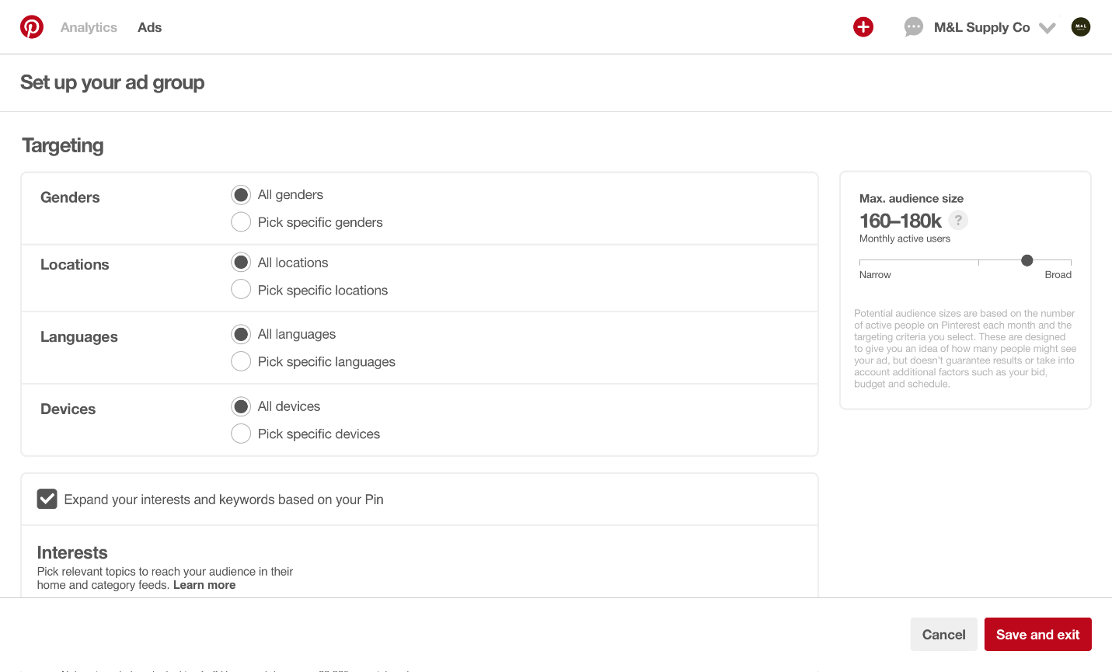

After completing this process, we will save and exit, and then Launch our Pin. It will go for quick review. After reviewing, Pinterest will promote the pin in order to get more reach and impressions.

**Pinterest Analytics:**

Ads has been created and promoted. Now its time to check the results we got. We can get these analytics from Pinterest **Analytics** options on Pinterest Ads Manager.

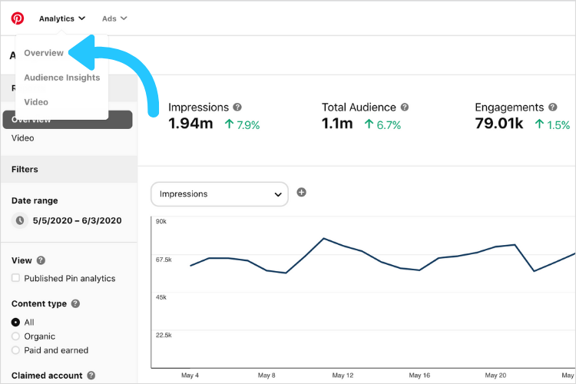

After clicking Overview, we will get the analytics of the pins we promoted. It will number of impressions, total audience and engagements.

**GOOGLE ADWORDS:**

Google AdWords is an online platform that is used for advertising purpose. It is the most powerful platform used for digital marketing. Companies pay per click to google to advertise their keywords on google search engine and other google network. The system used by AdWords is bidding system. Advertisers bid to have their ads shown to relative audiences on google search engine and other google platforms.

**Types of Google Ads:**

There are 7 types of ads supported by google AdWords:

**Search Ads:** Search ads run on google search engine as the keywords entered by interested customers.

**Display Ads:** These ads are in the form of image that runs on website.

**Shopping Ads**: E-commerce products can be promoted by using shopping ads on e-commerce platforms.

**Video Ads:** these ads are used to get engagement and reach on YouTube and web videos.

**App Ads:** these types of ads are used to promote applications.

**Smart Ads:** these are automated ads that run on Google and Across the web.

**Discovery Ads:** These ads run on YouTube, Gmail, Discover and other platforms.

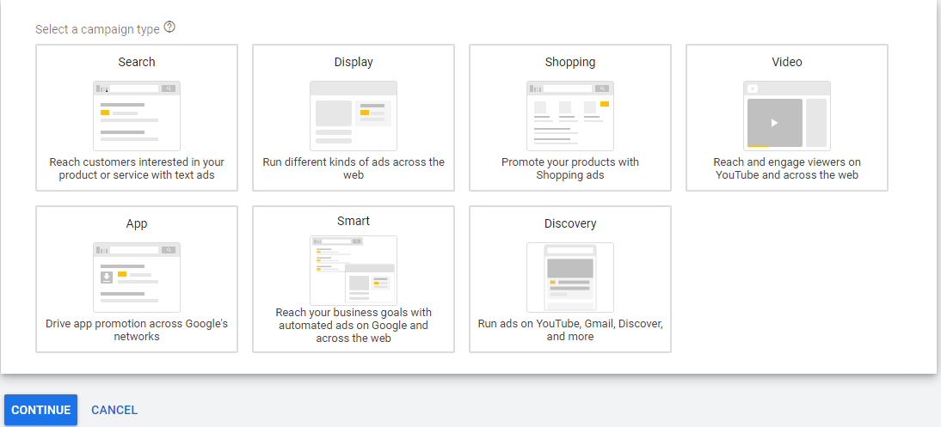

**AdWords Campaign for Virtual Psychotherapist:**

First of all, we need to sign up to the Google AdWords account from out Google Account. After signing in, it will move towards AdWords Interface from where we can start our campaigns. AdWords provides two types of interfaces, one for beginners and other for experts. We have worked on expert mode. From **+ New Campaign** icon we will start creating an ad. This is how an AdWords interface looks like:

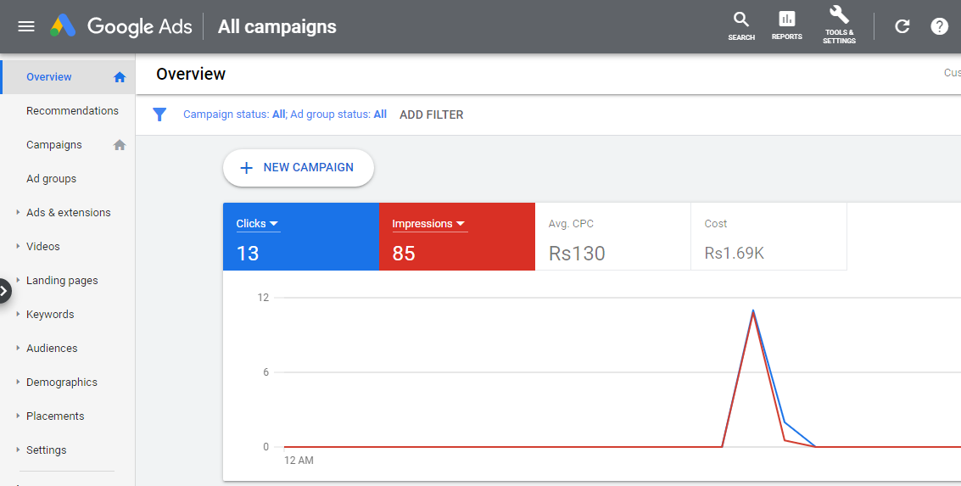

It will ask for the objective of our campaign:

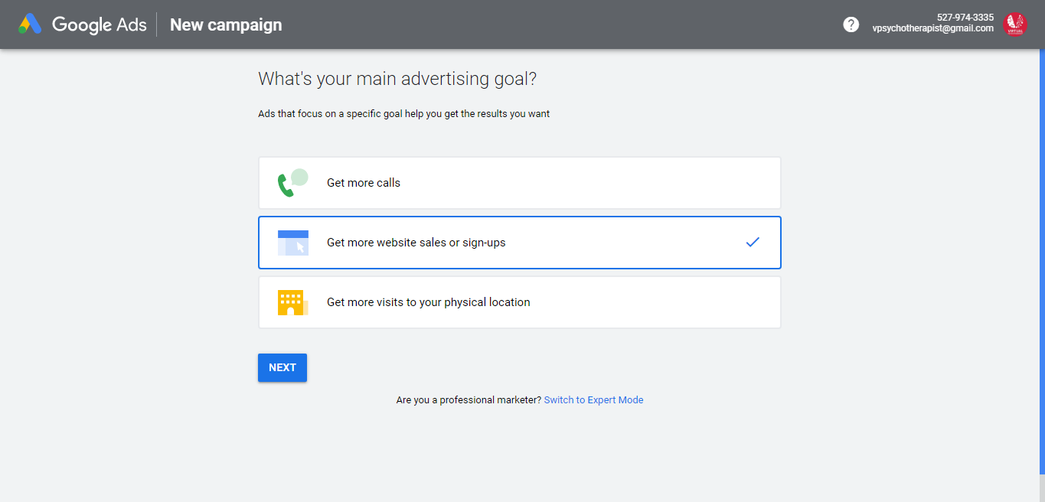

Then we need to put other information like business, demographics, keywords, location, budget and cost per view.

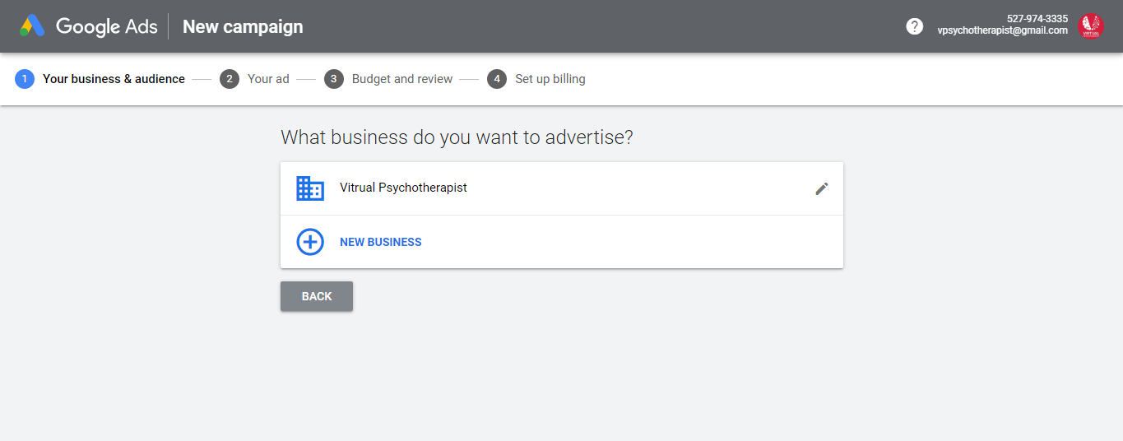

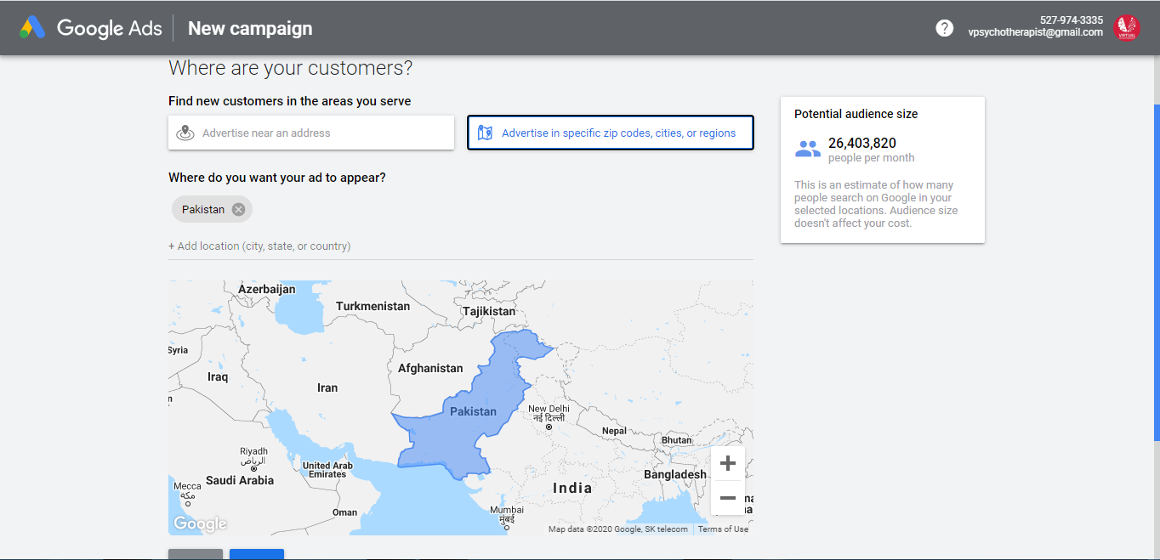

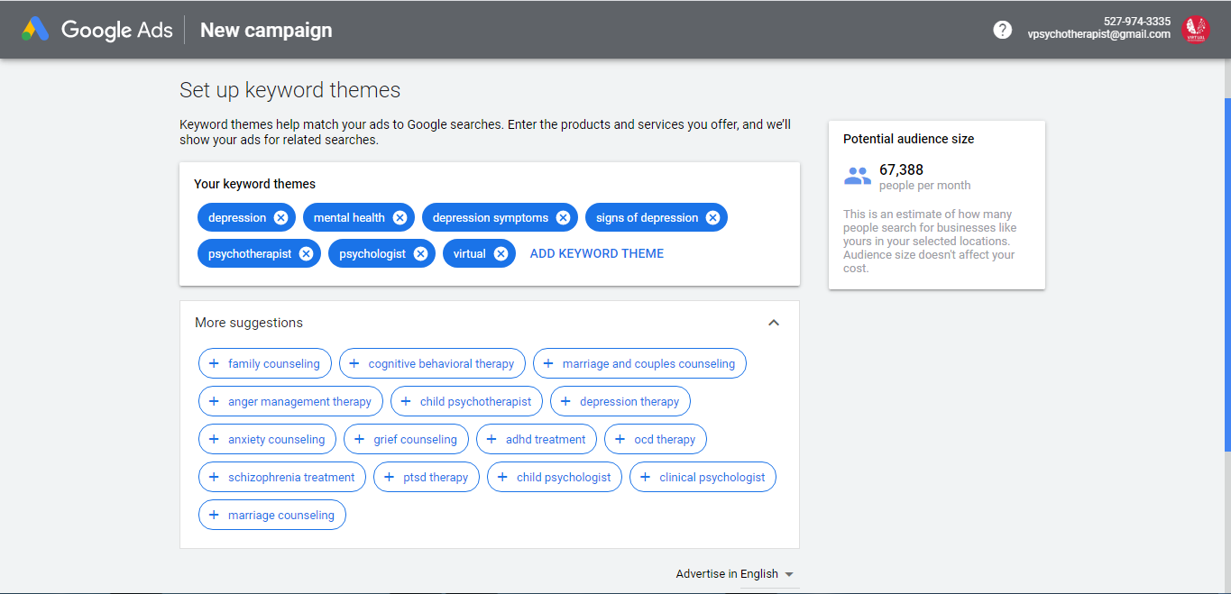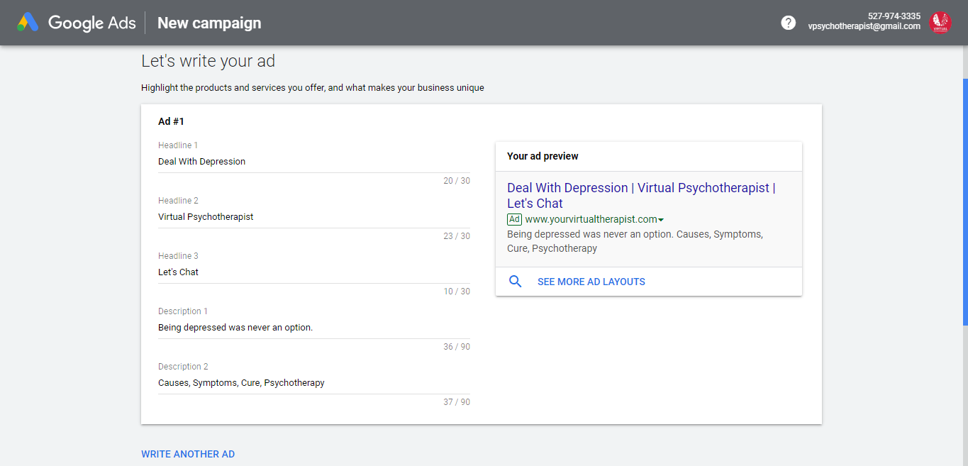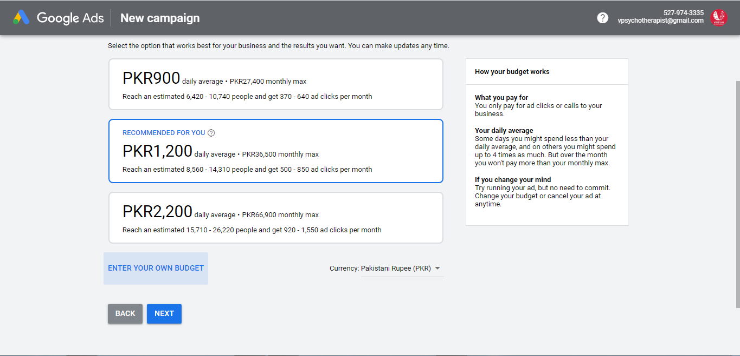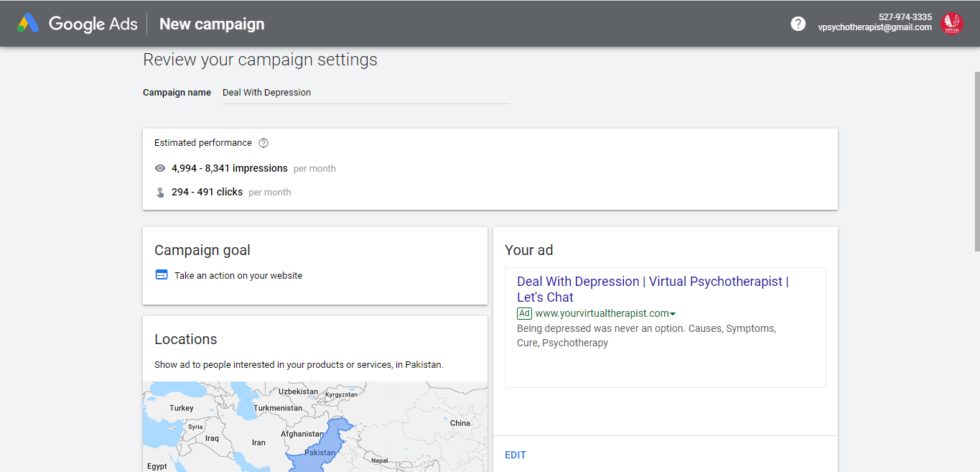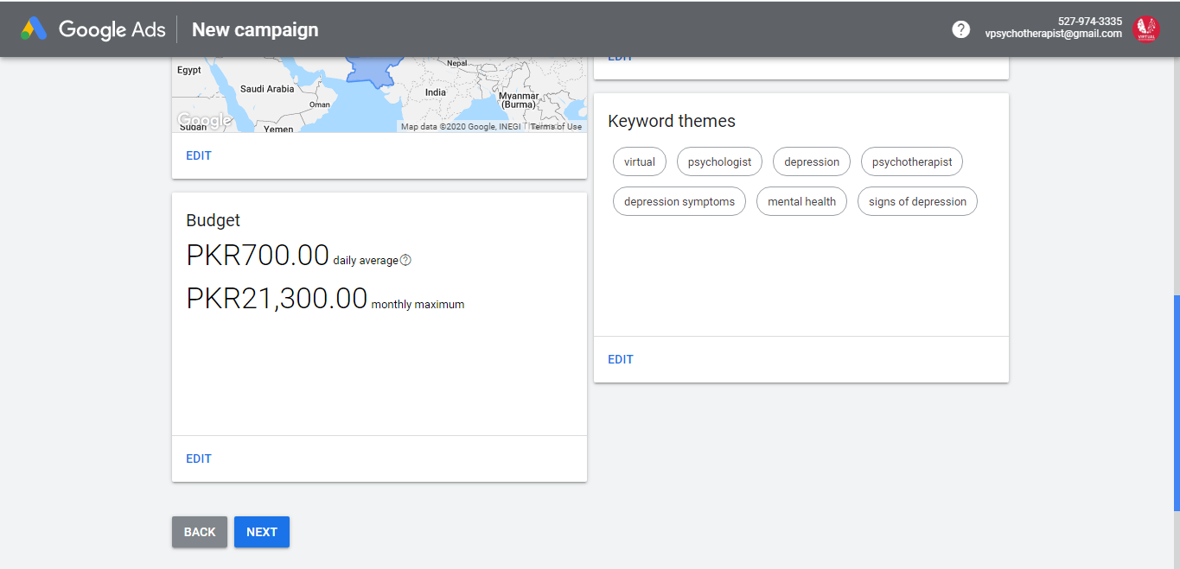

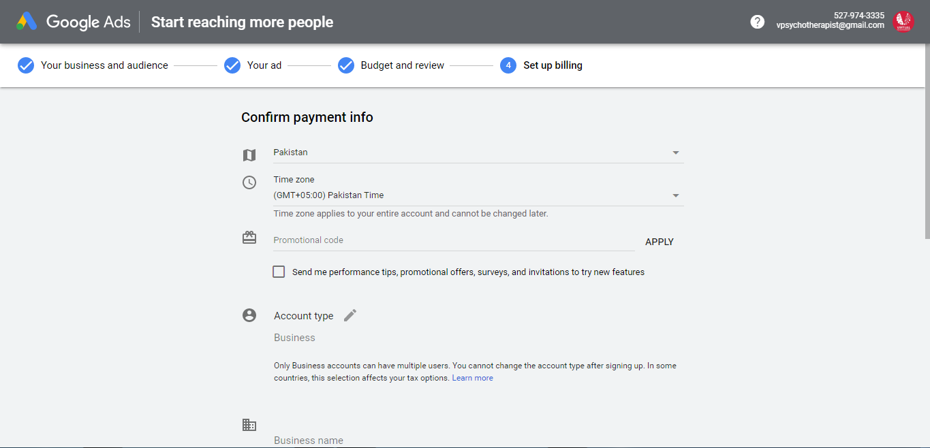

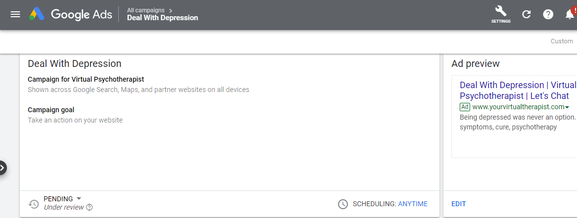

**Discovery Video Ad Campaign of Virtual Psychotherapist from AdWords to Run on YouTube Platform or Videos:**

We will select an objective for our Campaign.

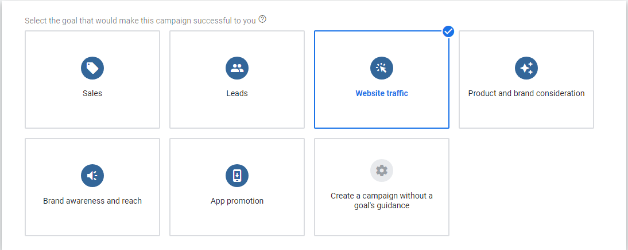

Then we need to put other information like business, video ad link, demographics, keywords, location, budget, cost per view. We also have an option for skippable and non-skippable ads.



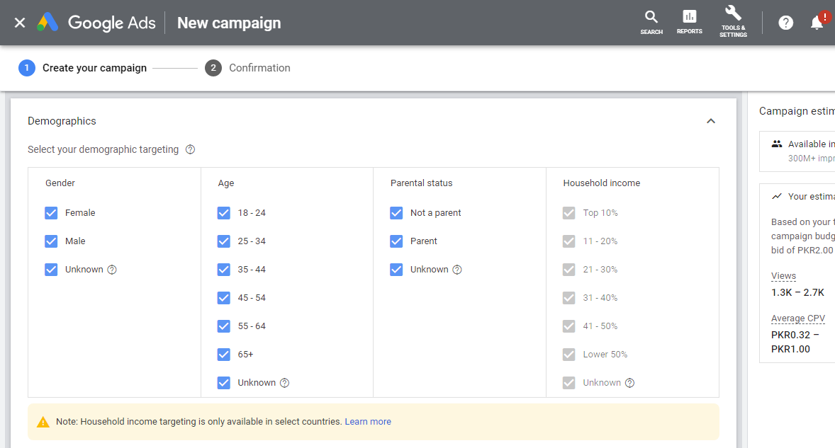

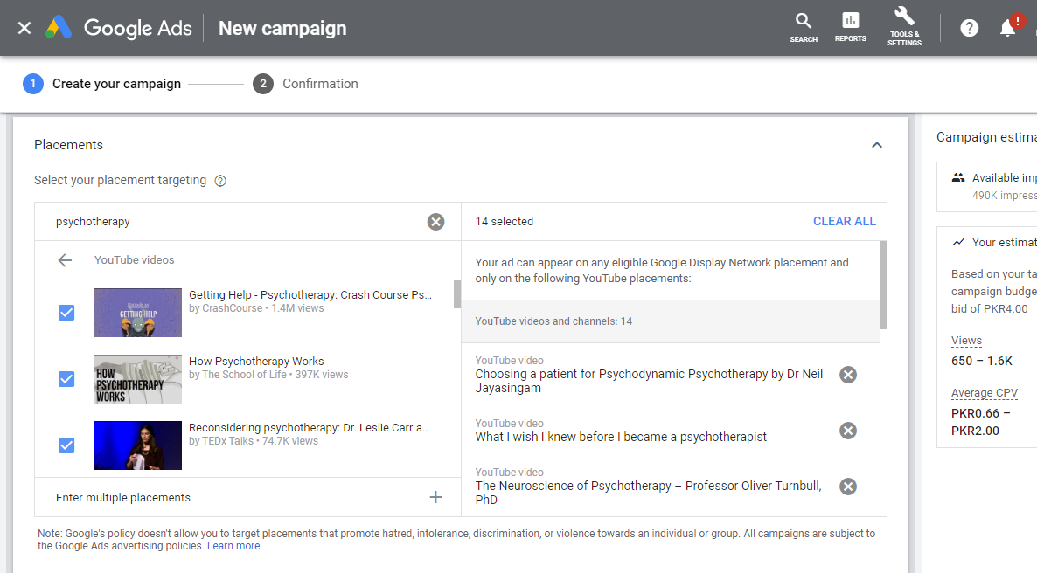

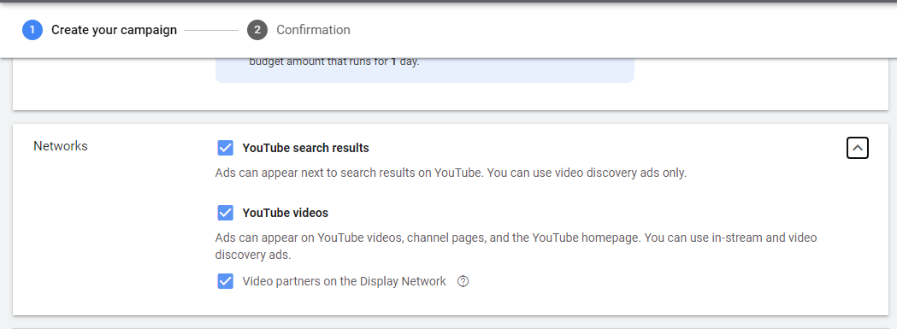

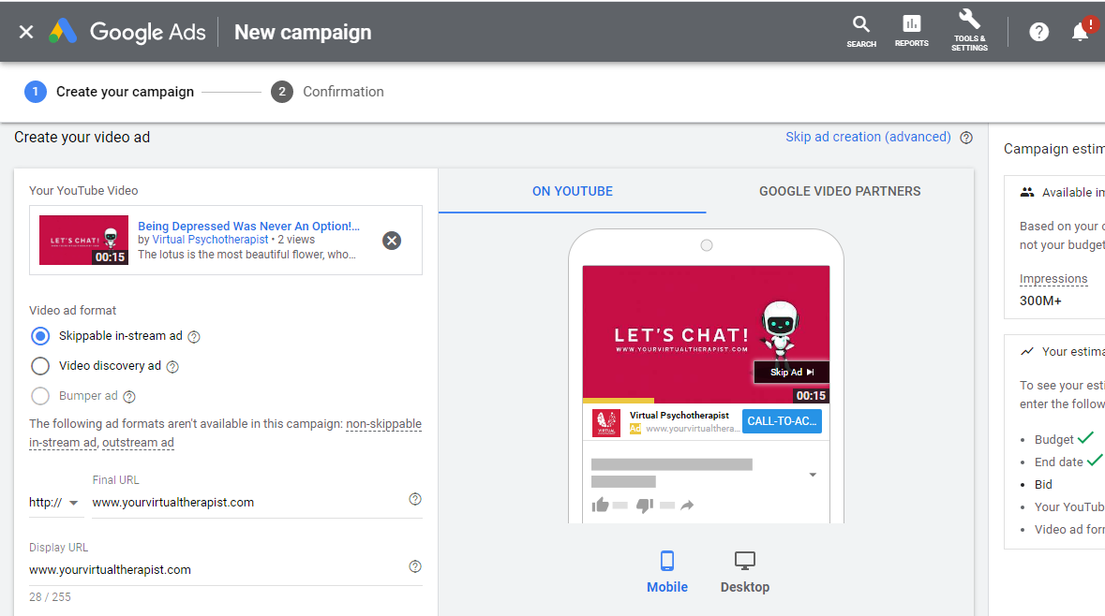

After giving all necessary information, our ad will go for a review and will start running wen approved.

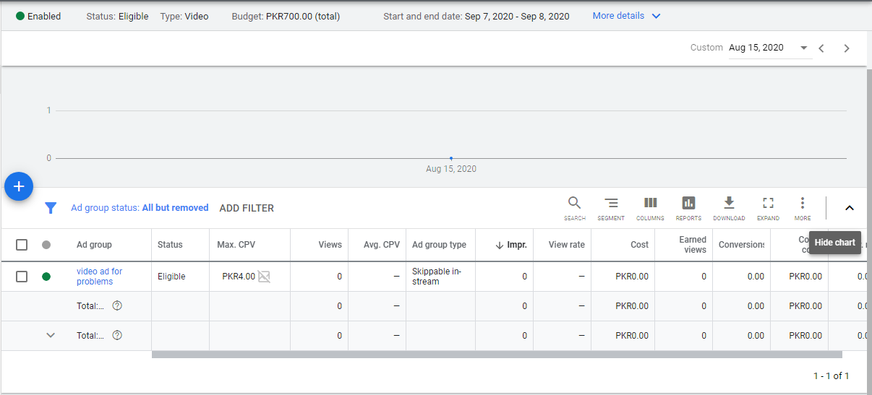

We can check results of our ads through Google Analytics.

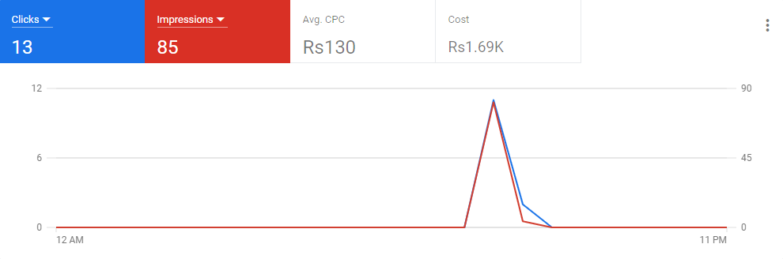

**BLOGGER.COM:**

Blogger.com is one the best official platform from where we can share information to lots of people. This platform can also be used for marketing purpose to spread information or to create an awareness related to your brand to people. Blogger.com allow users to create a unique and beautiful blog for free.

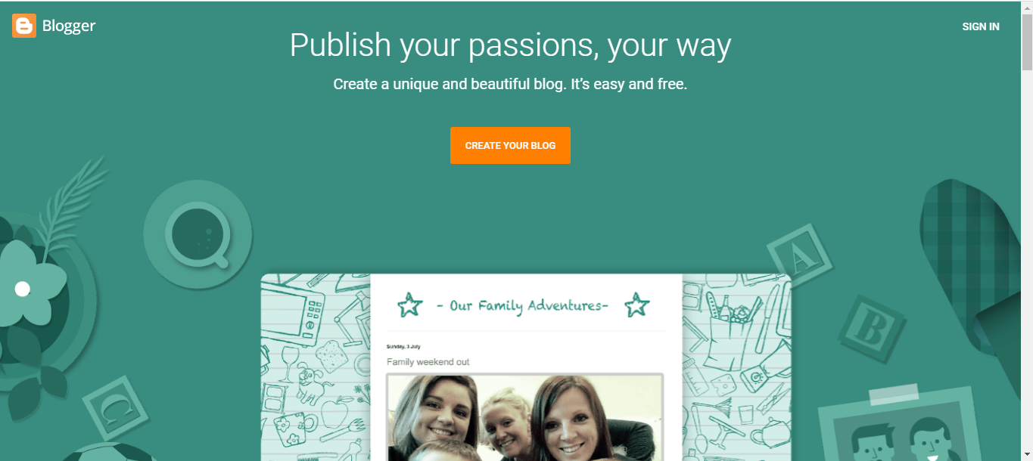

**Process of writing Blog for our Virtual Psychotherapist:**

After clicking on **Create Your Blog** Button, left navigation bar will allow us to create a new post for our blog. It provides lots of themes and layouts for blogs.

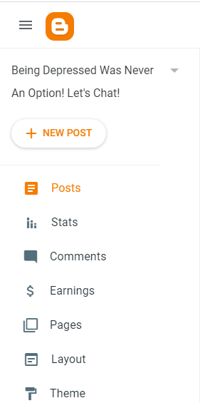

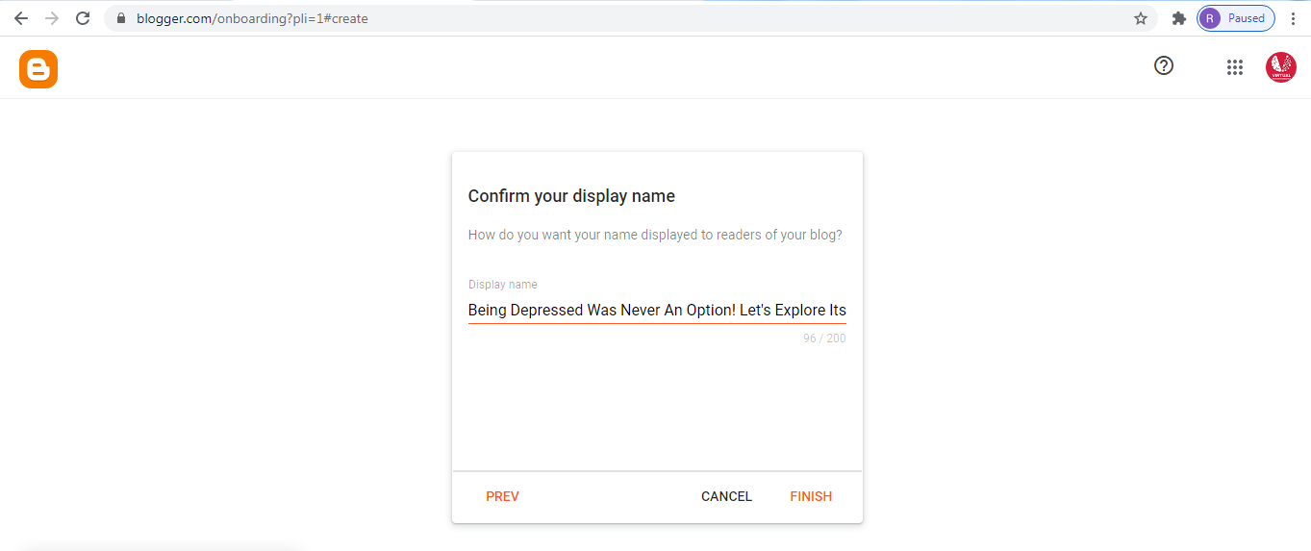

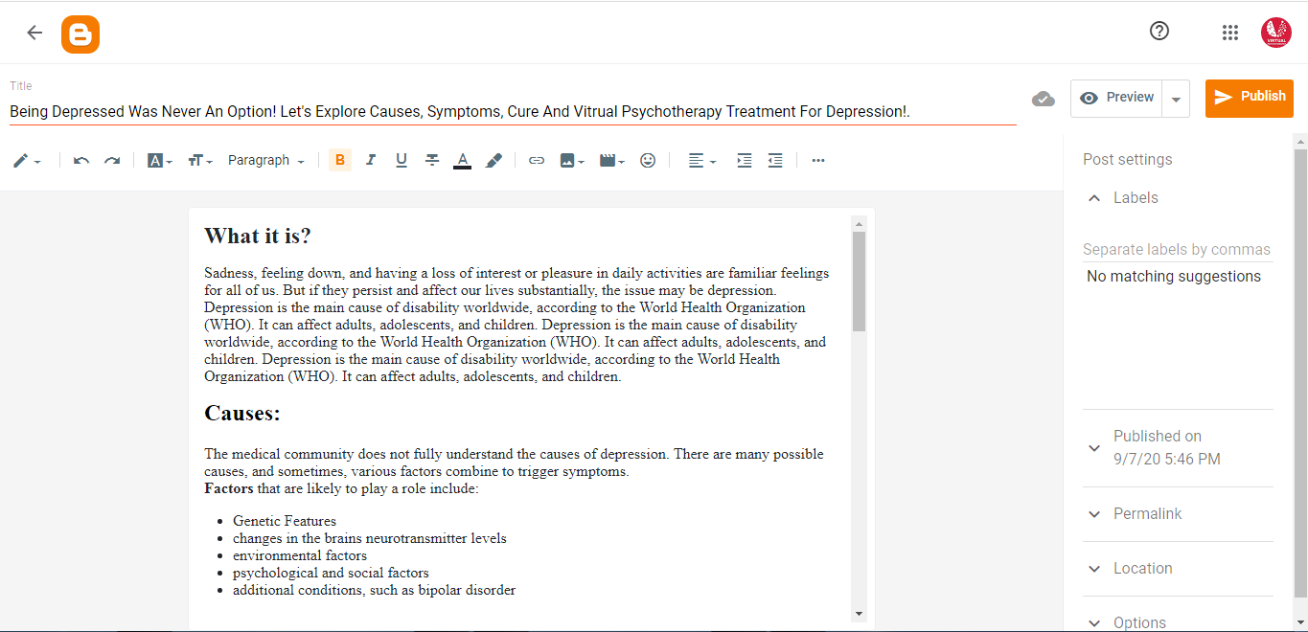

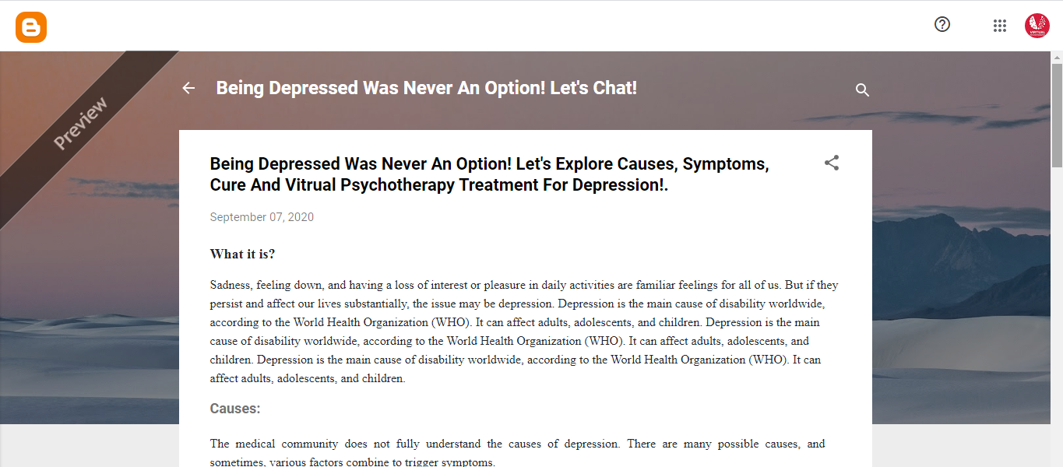

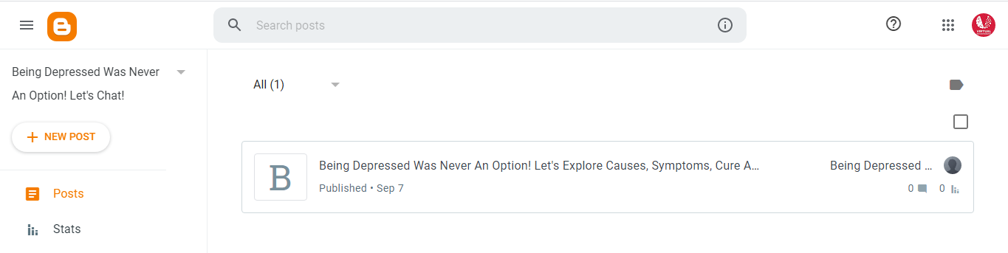  
And our blog for Virtual Psychotherapist has been written and published. This can be further shared on Facebook, Instagram, twitter and other social media platforms. People can view this blog and can ask questions related to this blog.

**MAILCHIMP.COM:**

Mailchimp is an Email Marketing Platform that allows businesses to send emails to their audience. It is a very powerful tool, as it sends email to multiple addresses in just single click. Its interface is very effective and easy to use. It helps small businesses to grow and talk to their clients and customers. It provides contact management, attractive campaign designs and data analysis features. All we need is to sign in to get started. After signing in the interface looks like this:

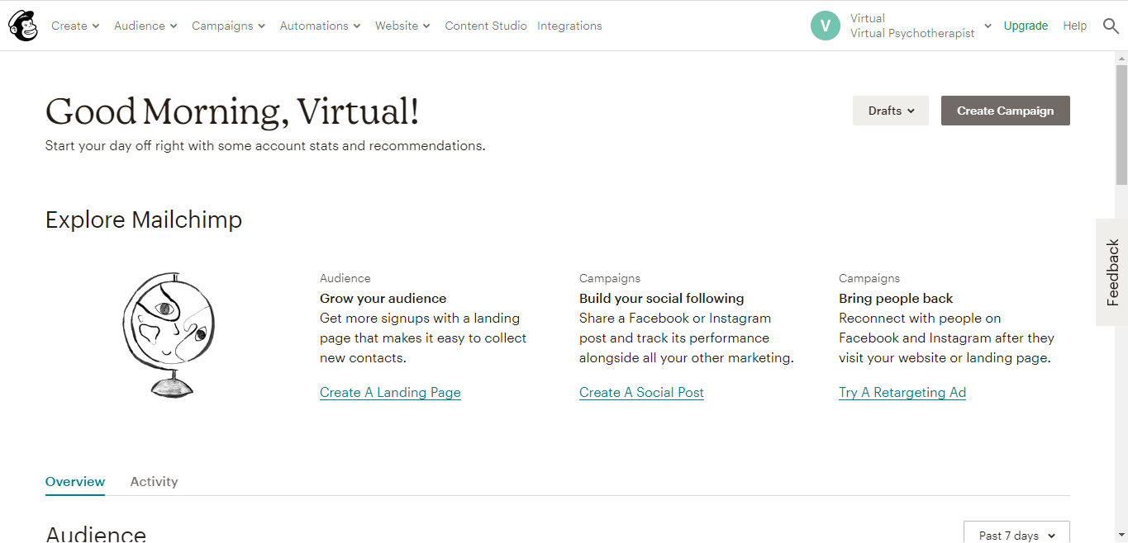

**Email Campaign for Virtual Psychotherapist.**

**Add Audience:**

First, we need to import audience/email list of our clients to send email messages. From **Create,** click on contacts to add audience. Let’s see the process:

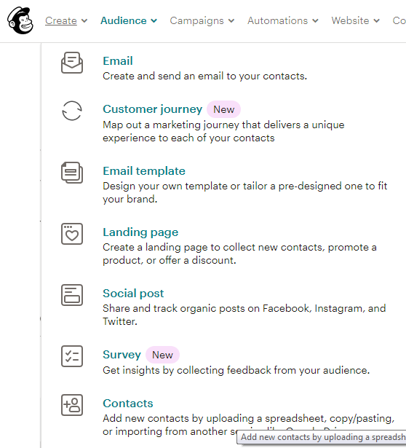

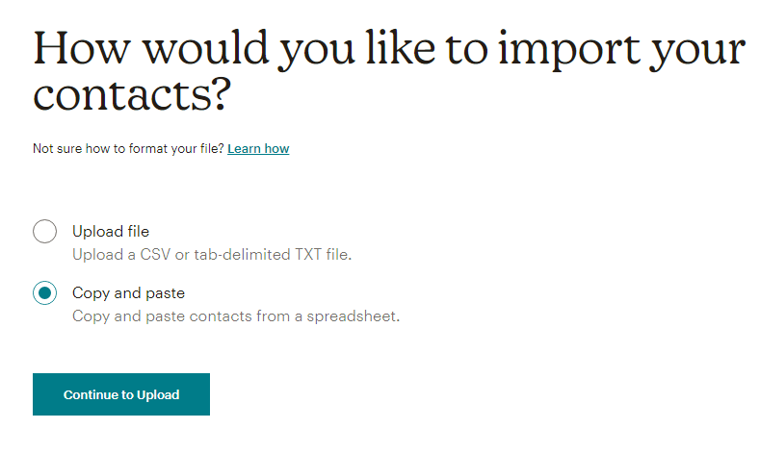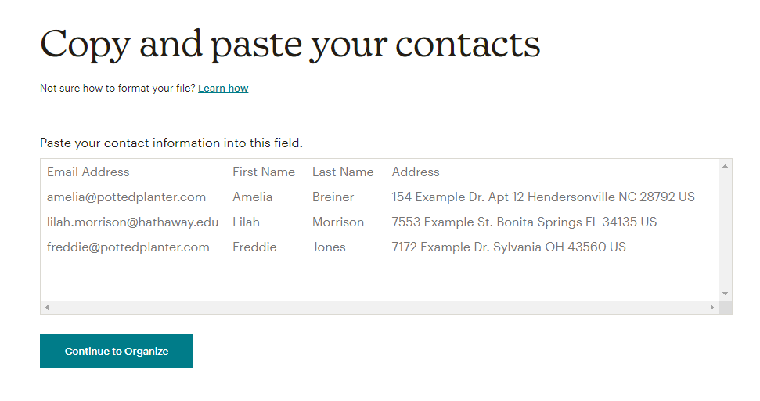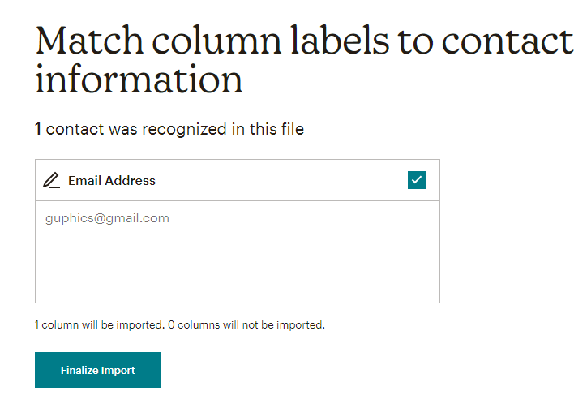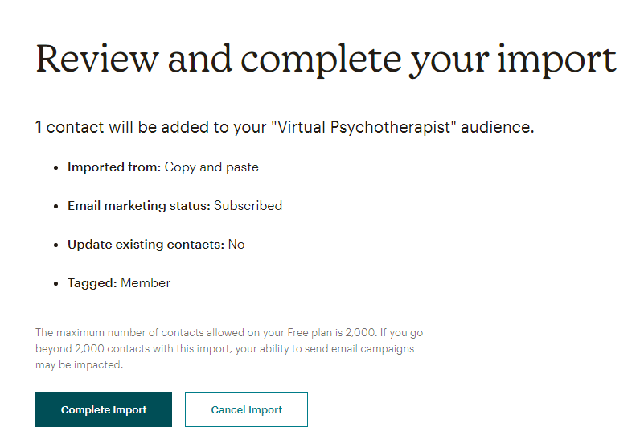

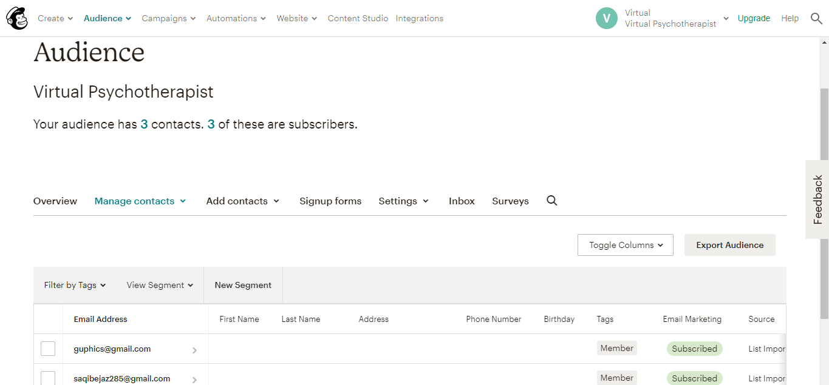

As we can see our audience has been added to our contacts.

**Start Campaign:**

From an Email campaign we will select **Campaign** from the top Menu. We will target our contacts as Recipient, will add subject and content for our email. Let’s explore how we created the campaign for VP.

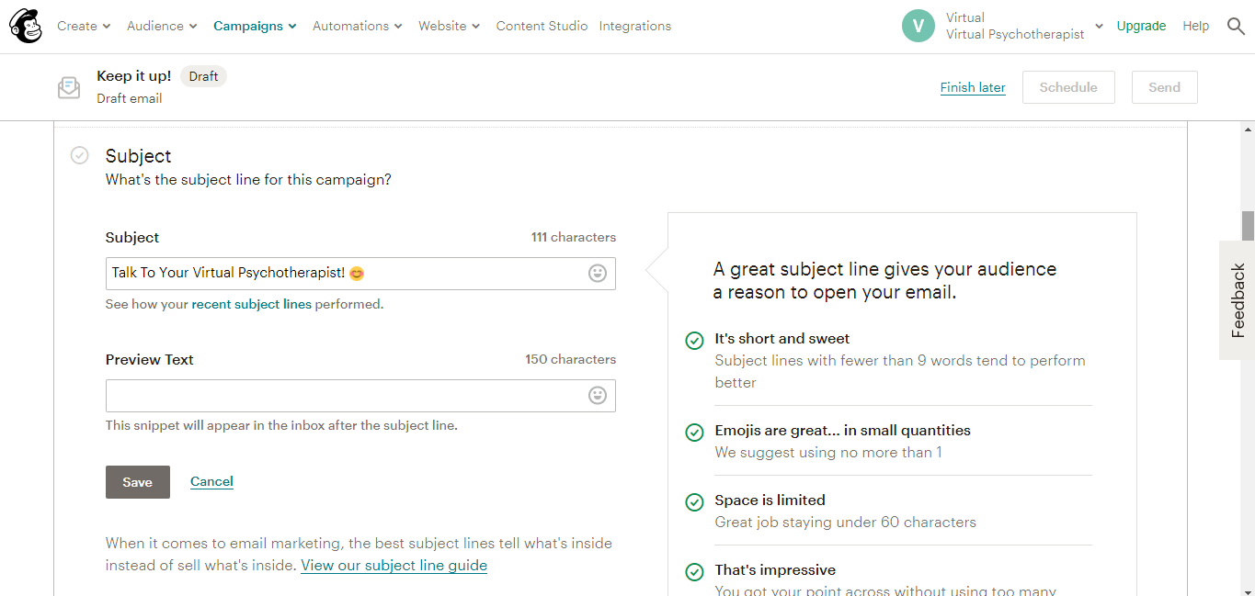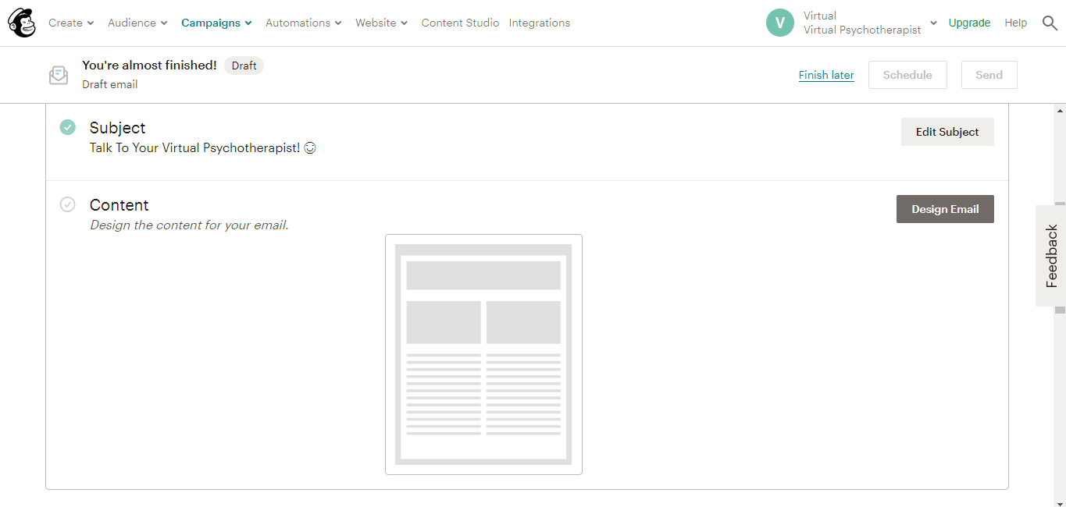

After clicking on content, it will show a lot of different layouts, themes, saved templates and will allow us to code our template according to our business nature.

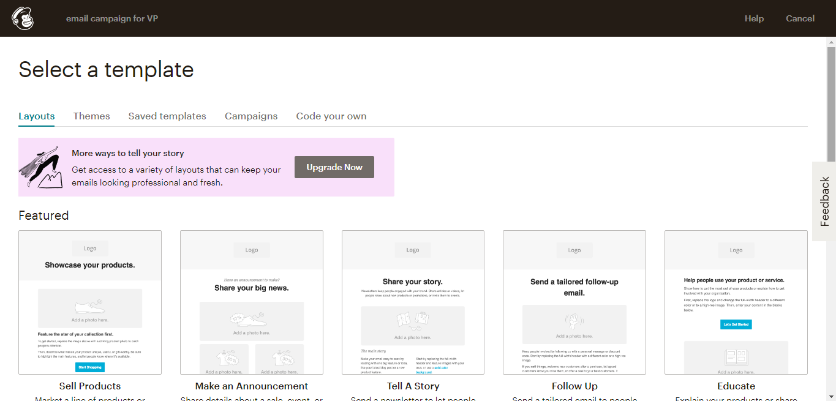

After Choosing a layout for our email, we can customize it according to our requirement.

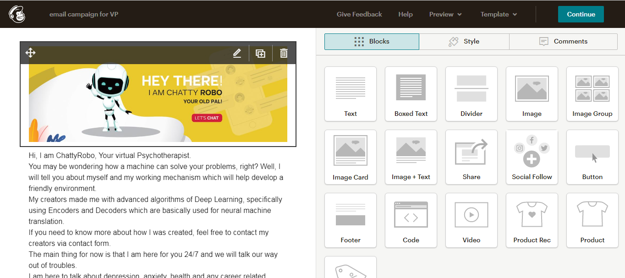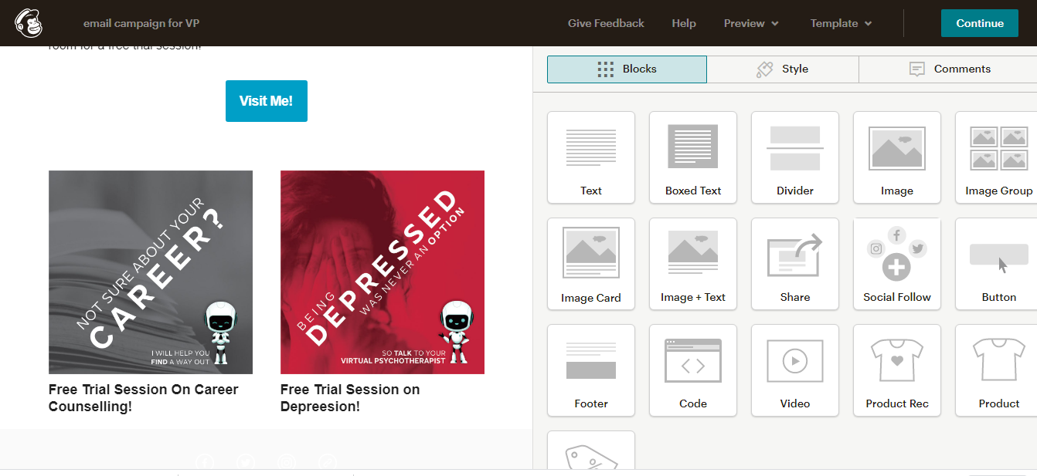

After customizing it, we need to click on continue and here we go…..

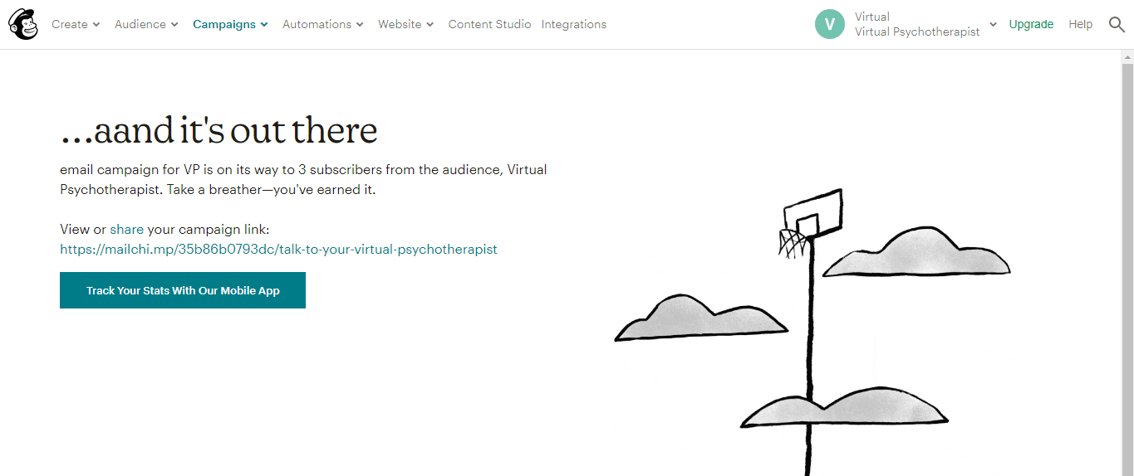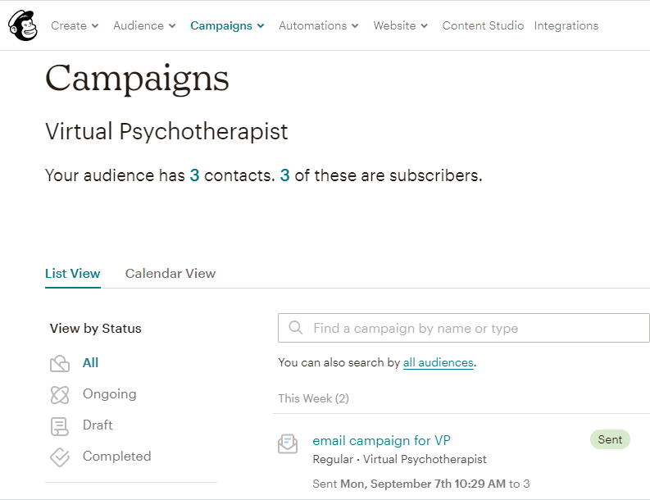

Our email message has been sent to our recipients. We can check stats of our email as well from campaigns dashboard.

**References:**

[1]<https://www.worldometers.info/world-population/>

[2]<https://www.internetworldstats.com/stats.htm>

[3]<https://www.statista.com/statistics/278414/number-of-worldwide-social-network-users/>

[4]<https://www.statista.com/statistics/218984/number-of-global-mobile-users-since-2010/>

[5]<https://www.statista.com/statistics/264810/number-of-monthly-active-facebook-users-worldwide/#:~:text=With%20over%202.7%20billion%20monthly,network%20ever%20to%20do%20so>.[5]

[6]<https://www.brandwatch.com/blog/facebook-statistics/#:~:text=There%20are%20over%2060%20million,will%20pay%20to%20promote%20posts>. [6]

[7]<https://www.statista.com/topics/2463/tumblr/>